|  |  |  |  |
| --- | --- | --- | --- |
| **Item** | **Progress** | **Contributors** | **Details/Milestones (dated)** |
| Bootable Linux Drive | Done | Alianna (main), Nolan, Kene, Blade | Completed - 12/7 |
| Customization 1 – KDE Plasma | Done | Alianna (main), Nolan, Kene, Blade | Completed - 12/9 |
| Customization 2 – GNOME Software | Done | Alianna (main), Nolan, Kene, Blade | Completed - 12/9 |
| icon.sh | Done | Nolan | Completed - 12/5 |
| cronjobs.sh | Done | Kene | Completed – 12/10 |
| create_backup.sh | Done | Kene | Completed – 12/10 |
| update_packages.sh | Done | Blade | Completed – 12/10 |
| update_network.sh | Done | Nolan | Completed – 12/10 |
| Presentation Video | Done | Nolan, Alianna, Kene, Blade | Completed – 12/11 |
| Documentation | Done | Nolan, Alianna, Kene, Blade | Completed – 12/11 |

Documentation Below, moved due to needed separate title page

**Title**: UNIX OS Final Project

**Team name**: Goofy Goobers

**Members**: Alianna Card, Nolan Haag, Blade Hagman, Kene Maduabum

**Youtube Presentation URL**: <https://youtu.be/6Ff-JxJYibQ>

[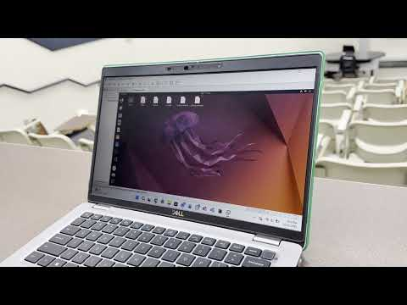](https://youtu.be/6Ff-JxJYibQ)

**Overview: Creating a customized USB Linux installation with integrated tools**

This project demonstrates creating a portable Linux operating system on an external drive with custom automation tools. We installed Ubuntu LTS on an external USB drive using Rufus to create a bootable installer, manually partitioning the drive with boot, swap, and root partitions. The system was then customized with KDE Plasma desktop environment and GNOME Software for enhanced usability. To extend functionality, we developed five bash scripts with Zenity graphical interfaces: *icon.sh* for creating desktop shortcuts, cronjobs.sh for scheduling automated tasks, *create_backup.sh* for directory backups, update_packages.sh for system maintenance, and *update_network.sh* for network diagnostics and updates.

**Linux Installation Steps:**

Download the ISO File:

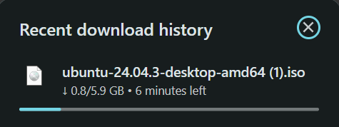

Download Rufus:

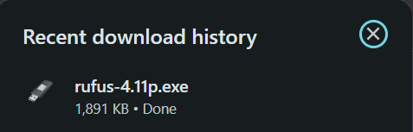

Creating a bootable USB with Rufus:

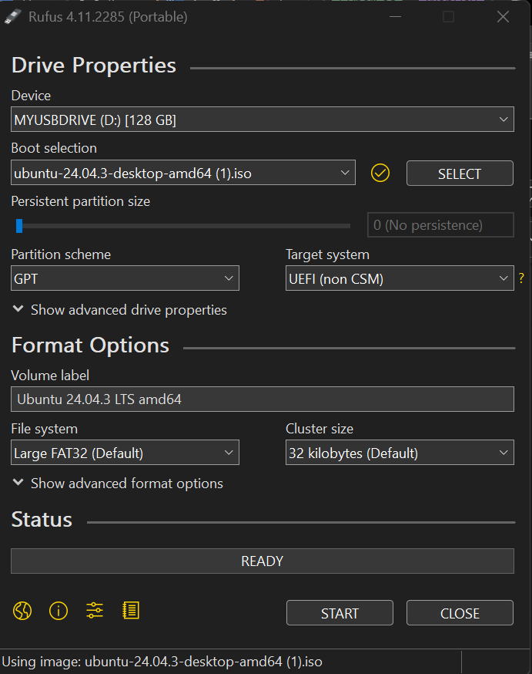

Then, I pressed START

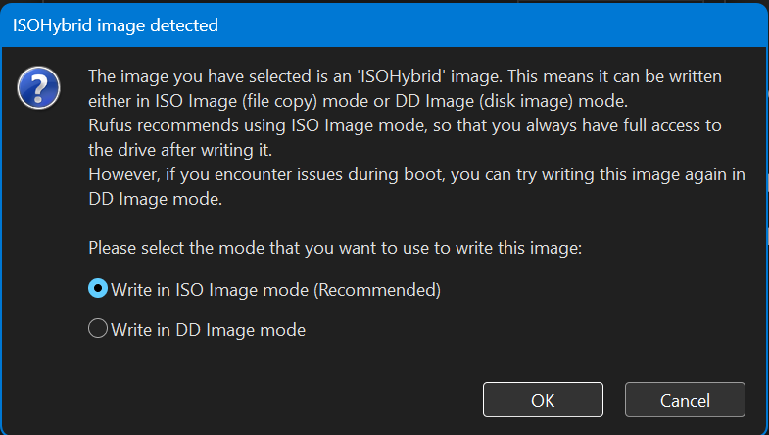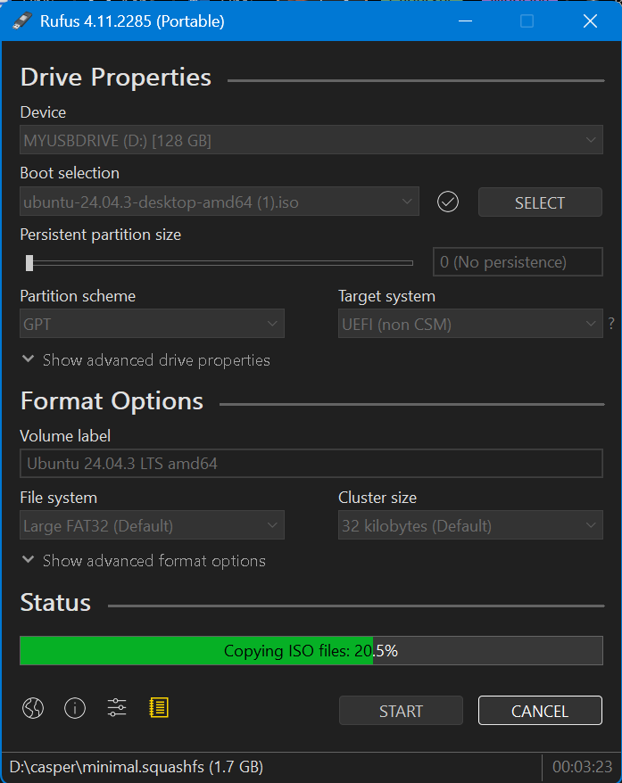

Boot from the USB:

After Rufus finished, I restarted my computer and pressed F12 once the Dell Logo appeared.

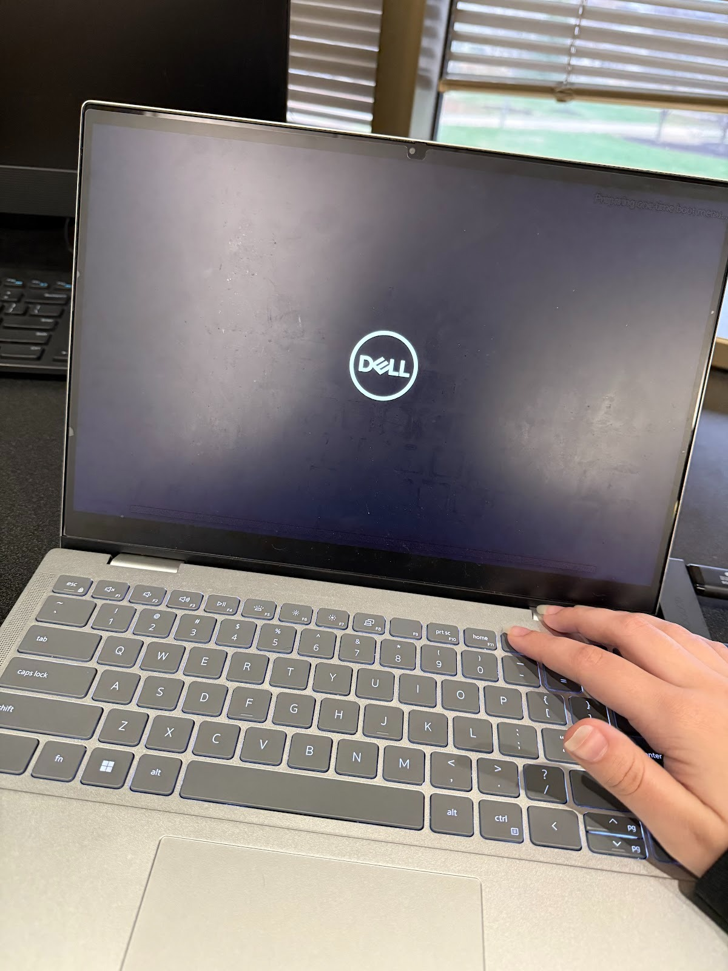

Then the one-time boot settings were pulled up, and I chose my USB to boot from with. Both my USB and external drive were plugged into my laptop

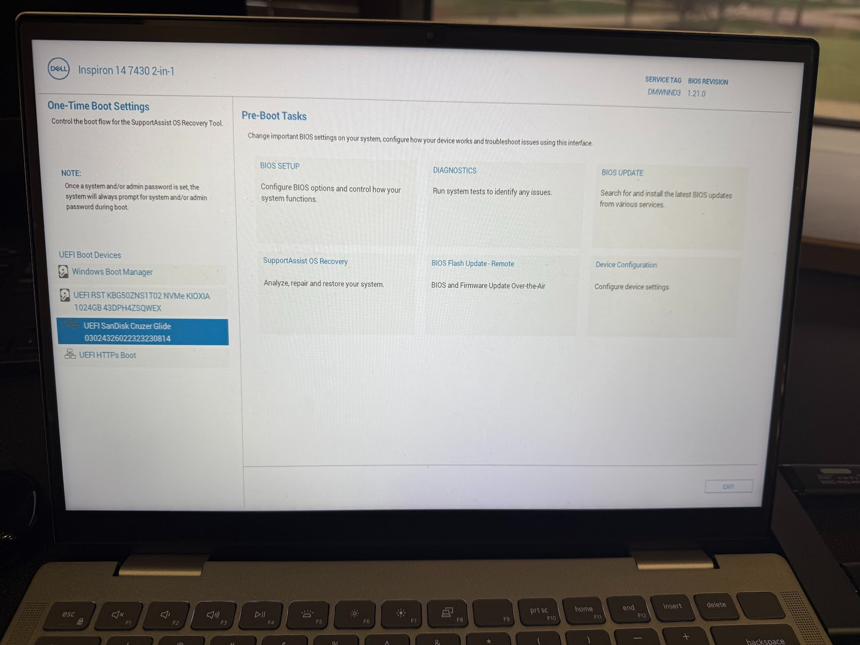

Installing Linux:

After booting from the USB, I chose the Try or Install Linux option.

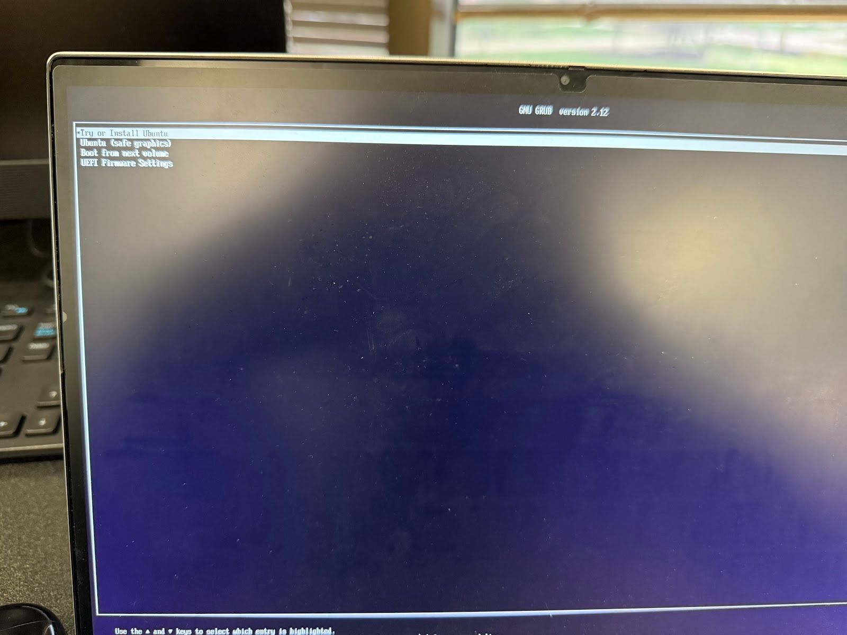

Ubuntu opened and I made basic selections such as the language and keyboard layout. I also connected it to my mobile hotspot (Tiger WIFI wasn’t working).

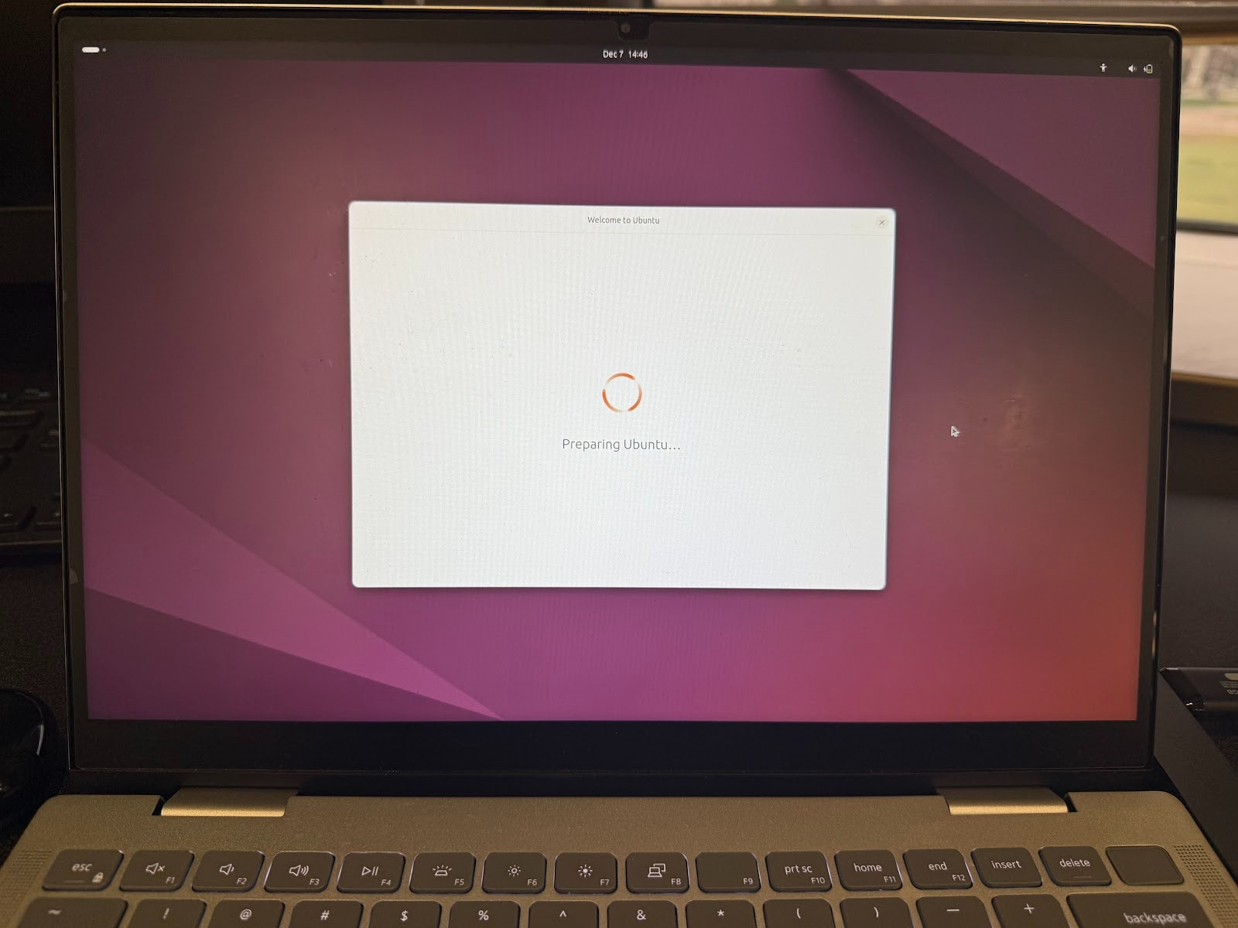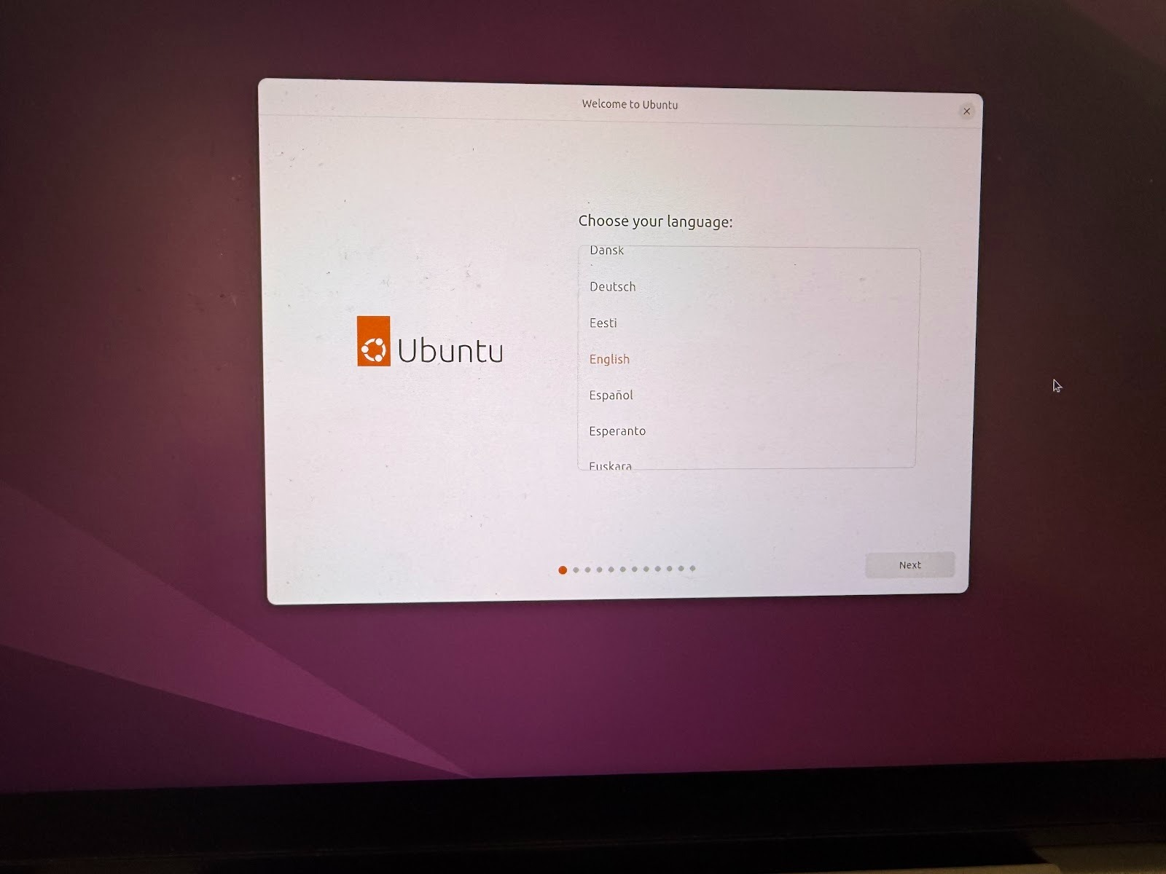

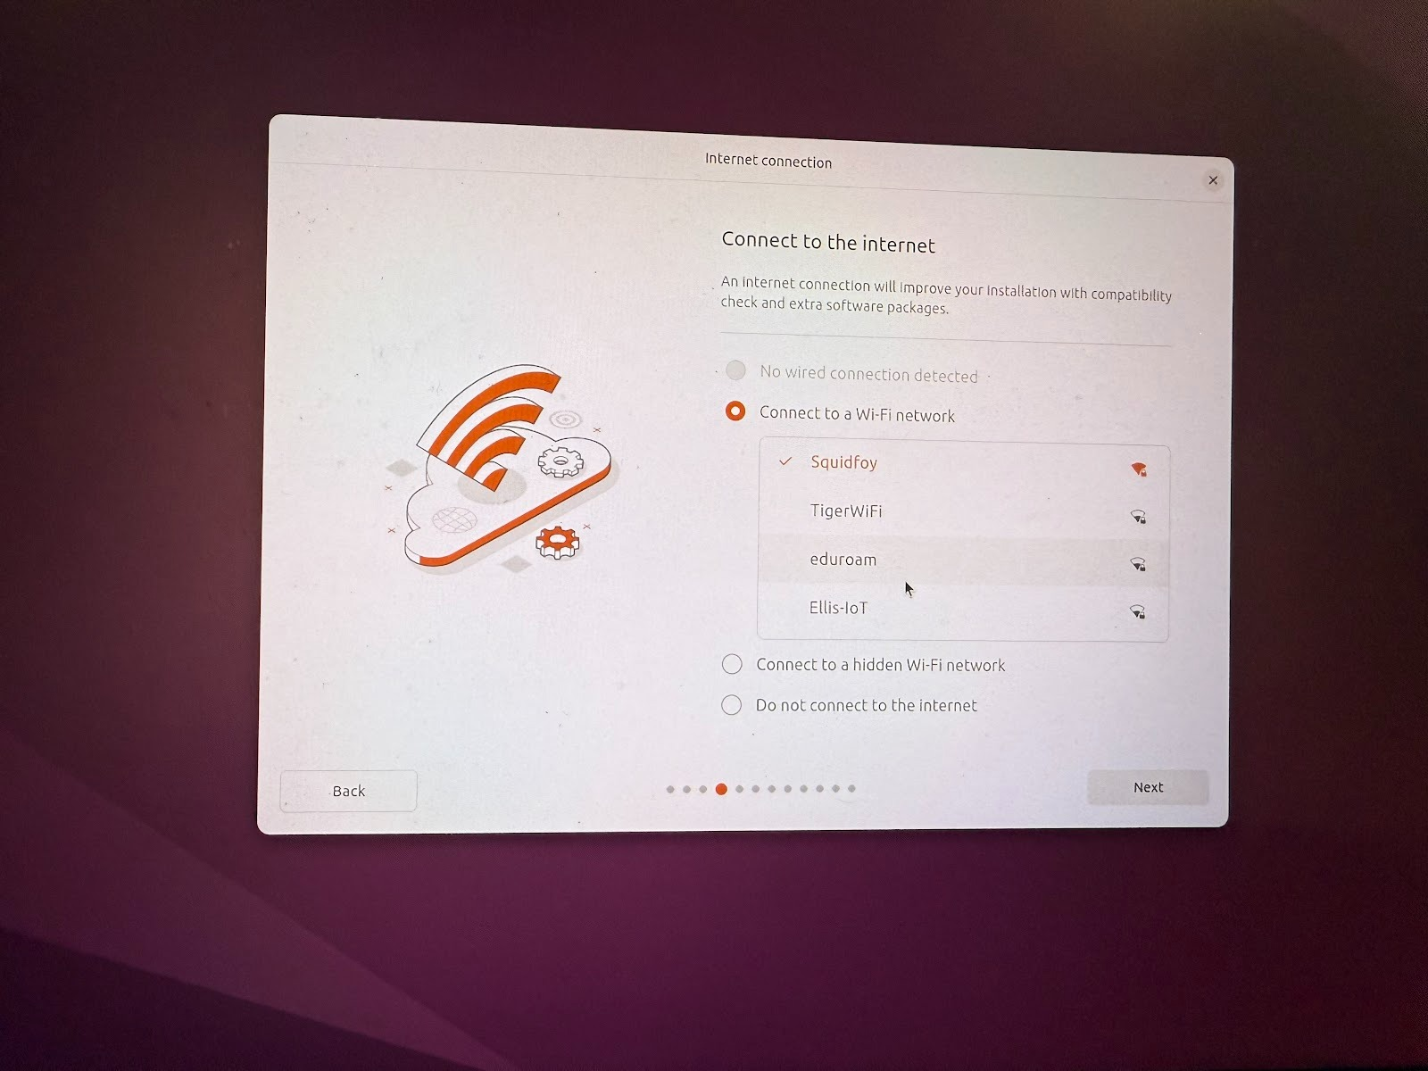

When asked how I wanted to install ubuntu, I chose manual installation so I could install it on my drive.

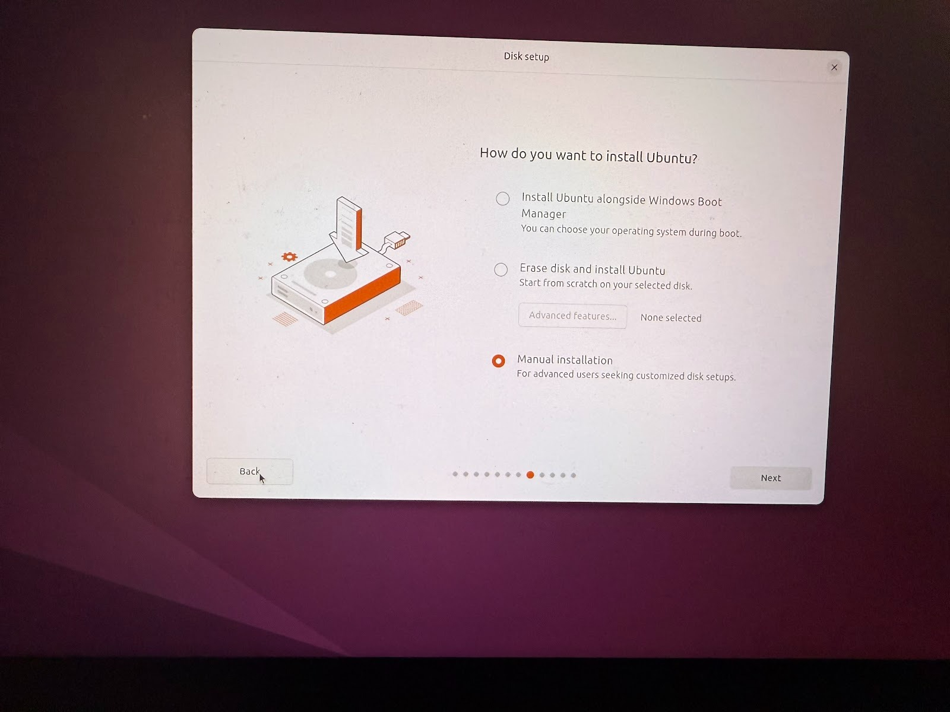

After chosing manual installation, I identified the correct device and deleted all the current partitions.

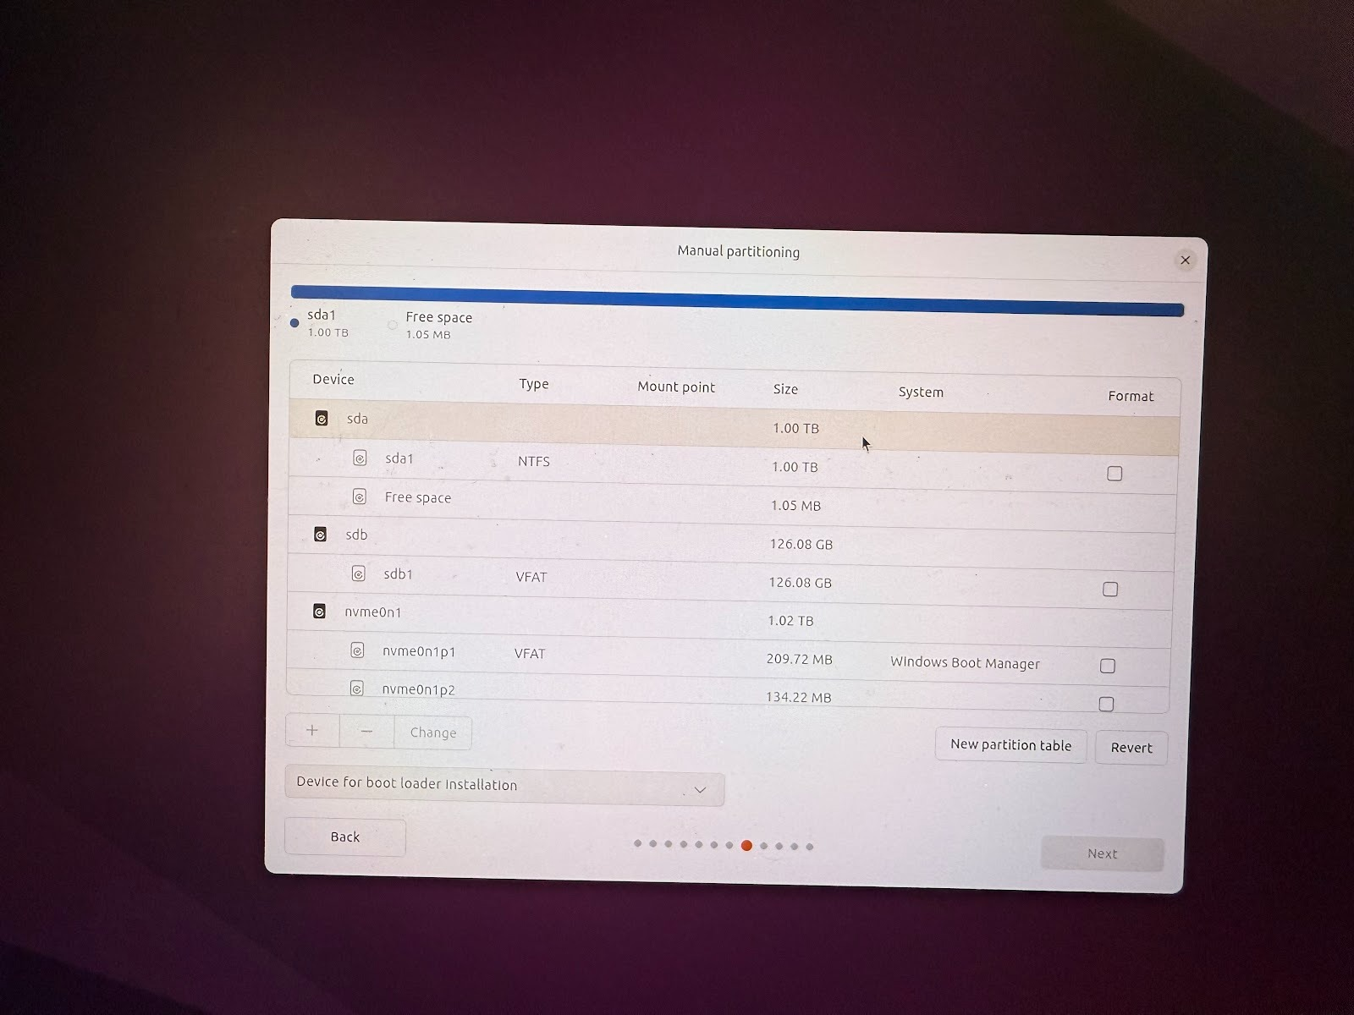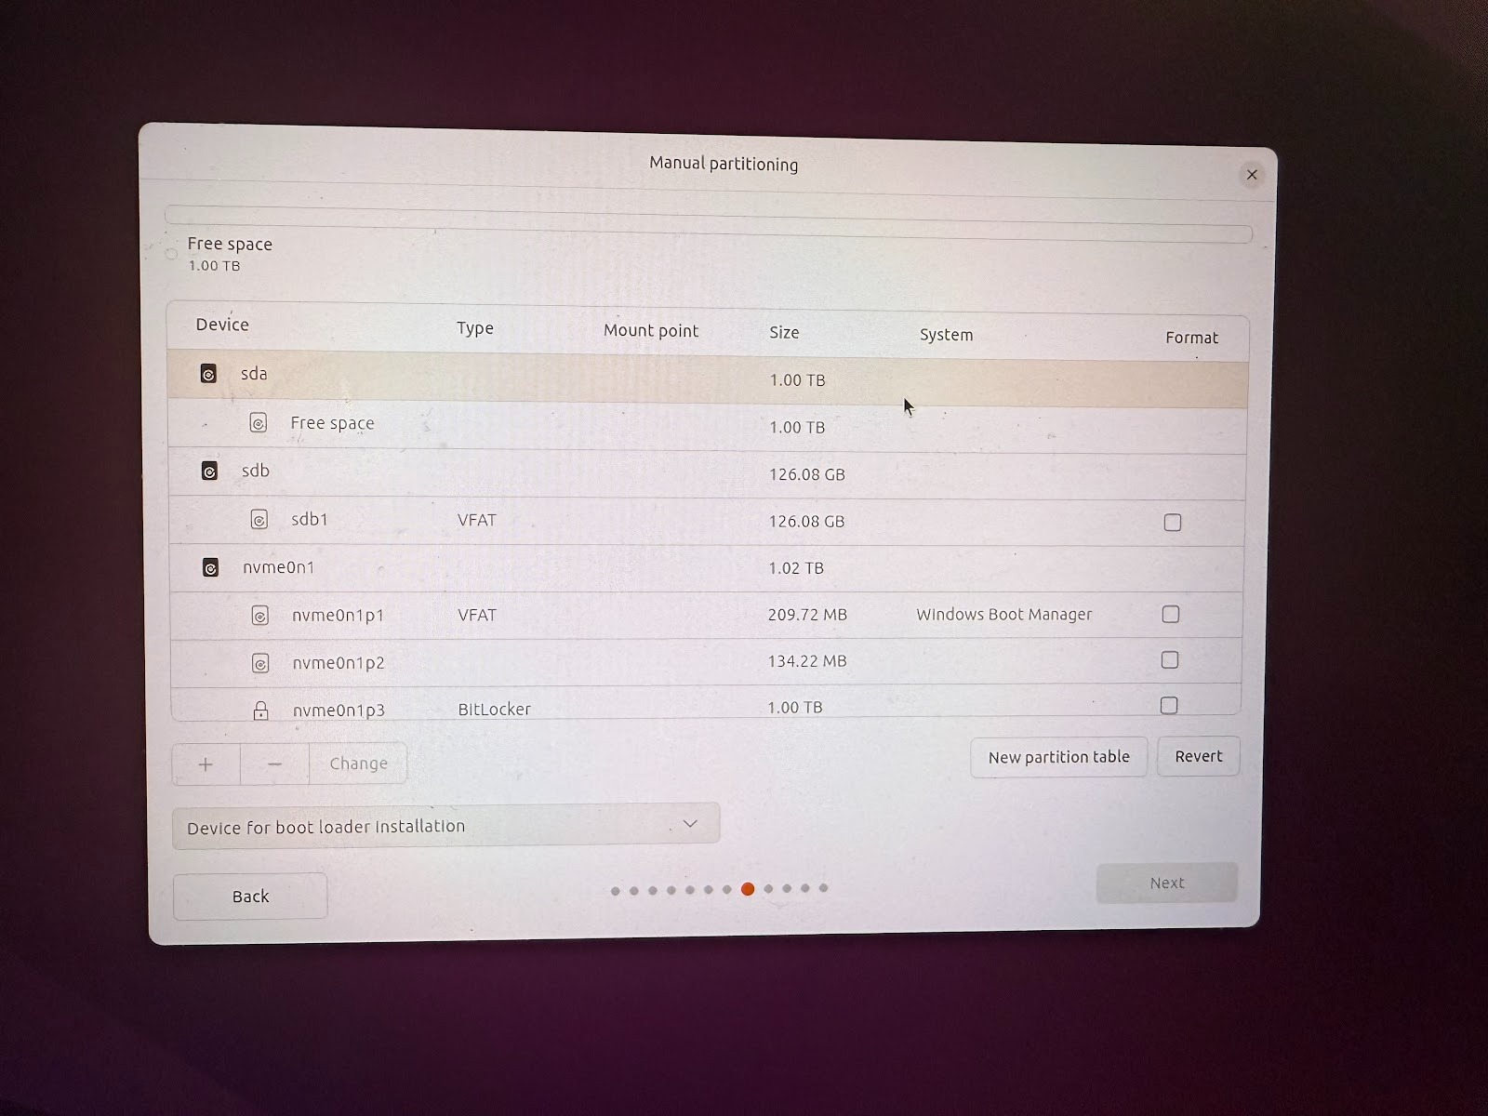

I manually partitioned it again. I made three partitions: Boot, Swap, and Root. Below pictures me creating the boot partition.

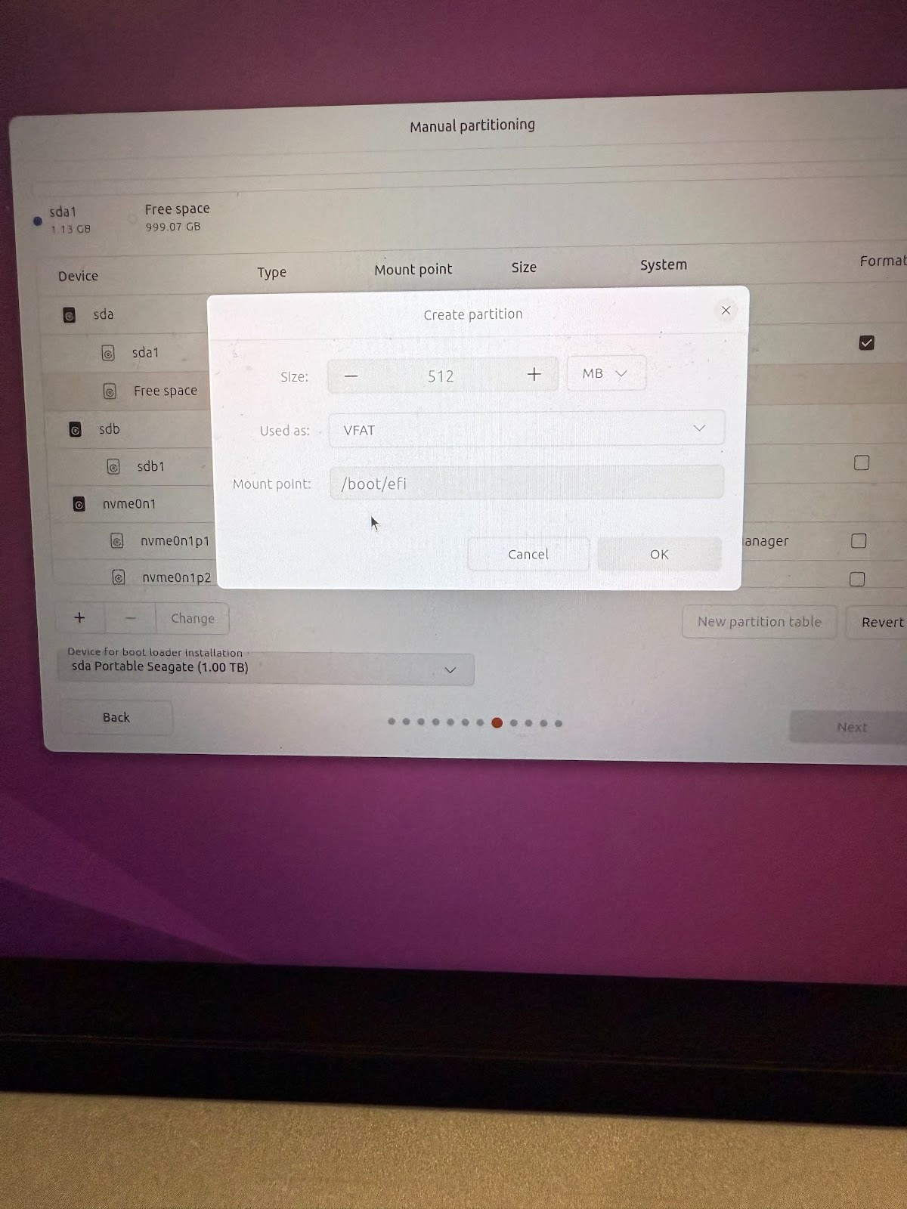

Below is an image of the final partitions I made (my external drive is sda).

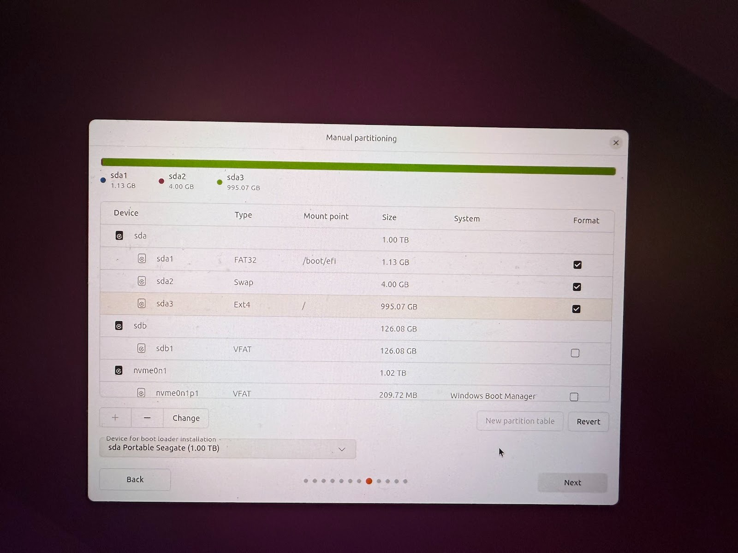

I then created my account and reviewed my choices.

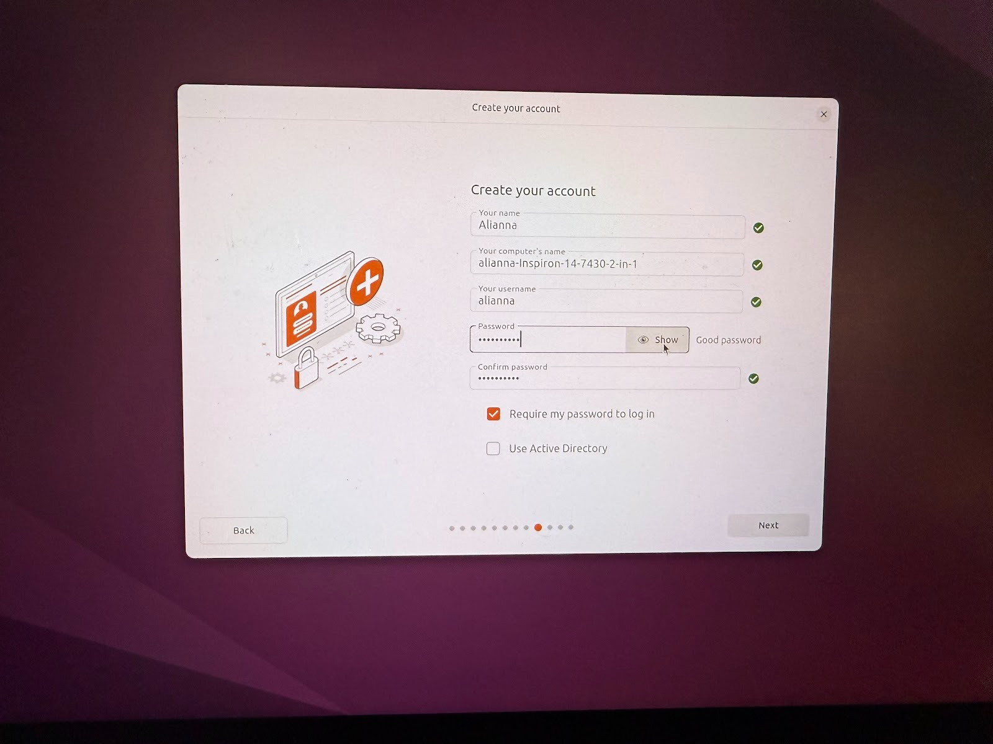 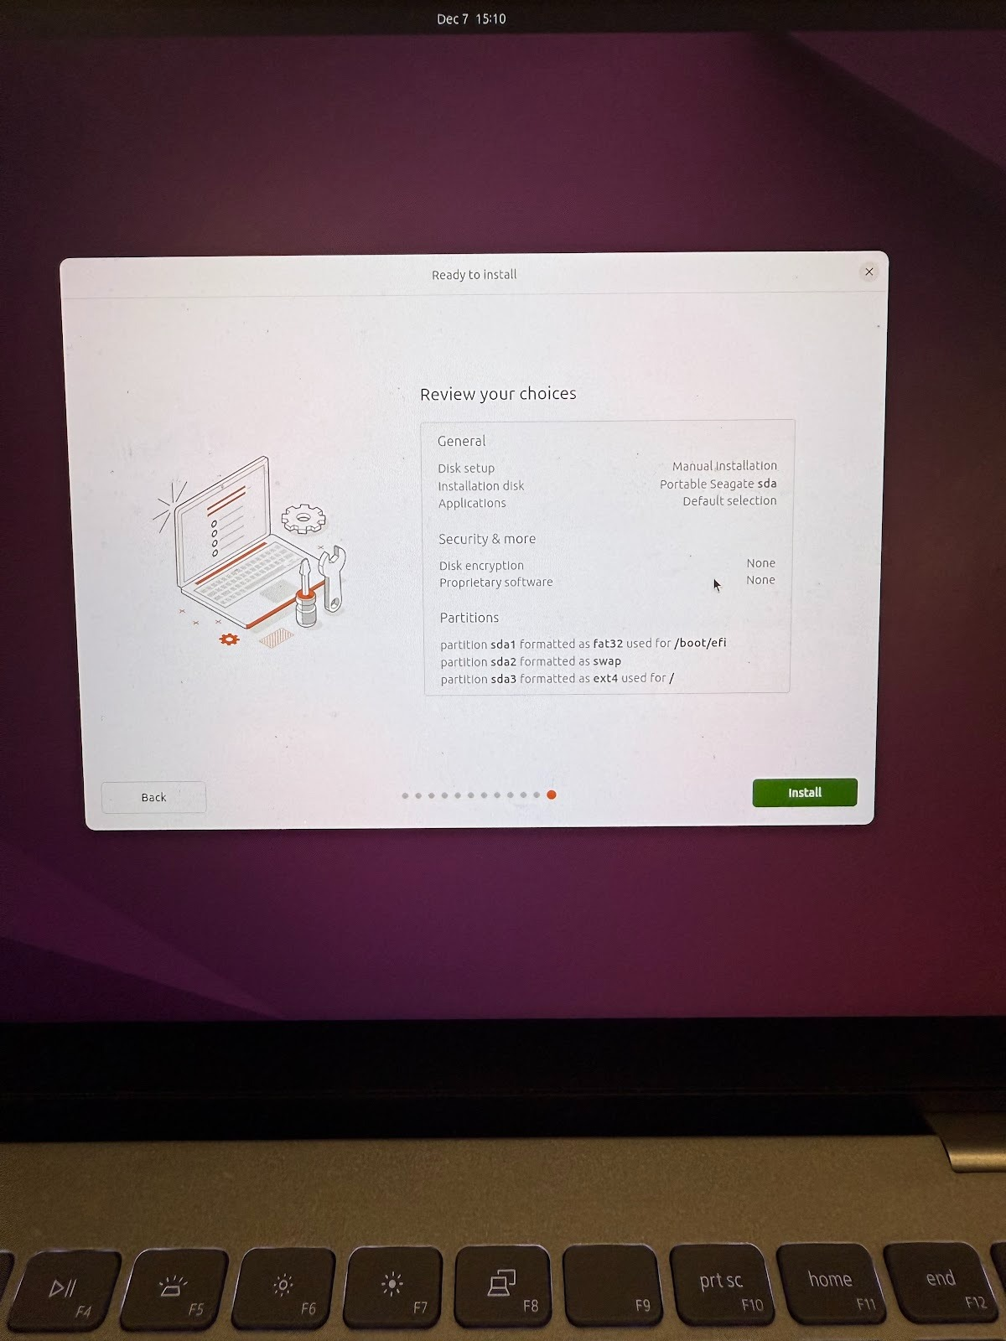

Finally, I waited about 20 minutes for Ubuntu to install and the drive was complete.

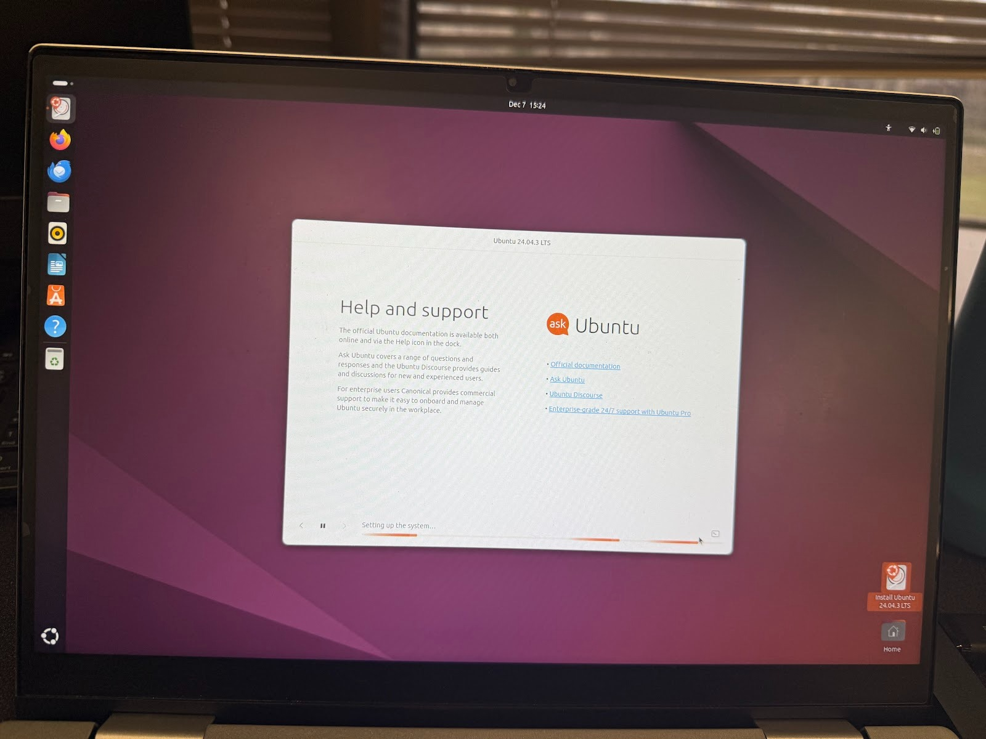

Then I went back to my windows machine and booted Linux up again to ensure it worked.

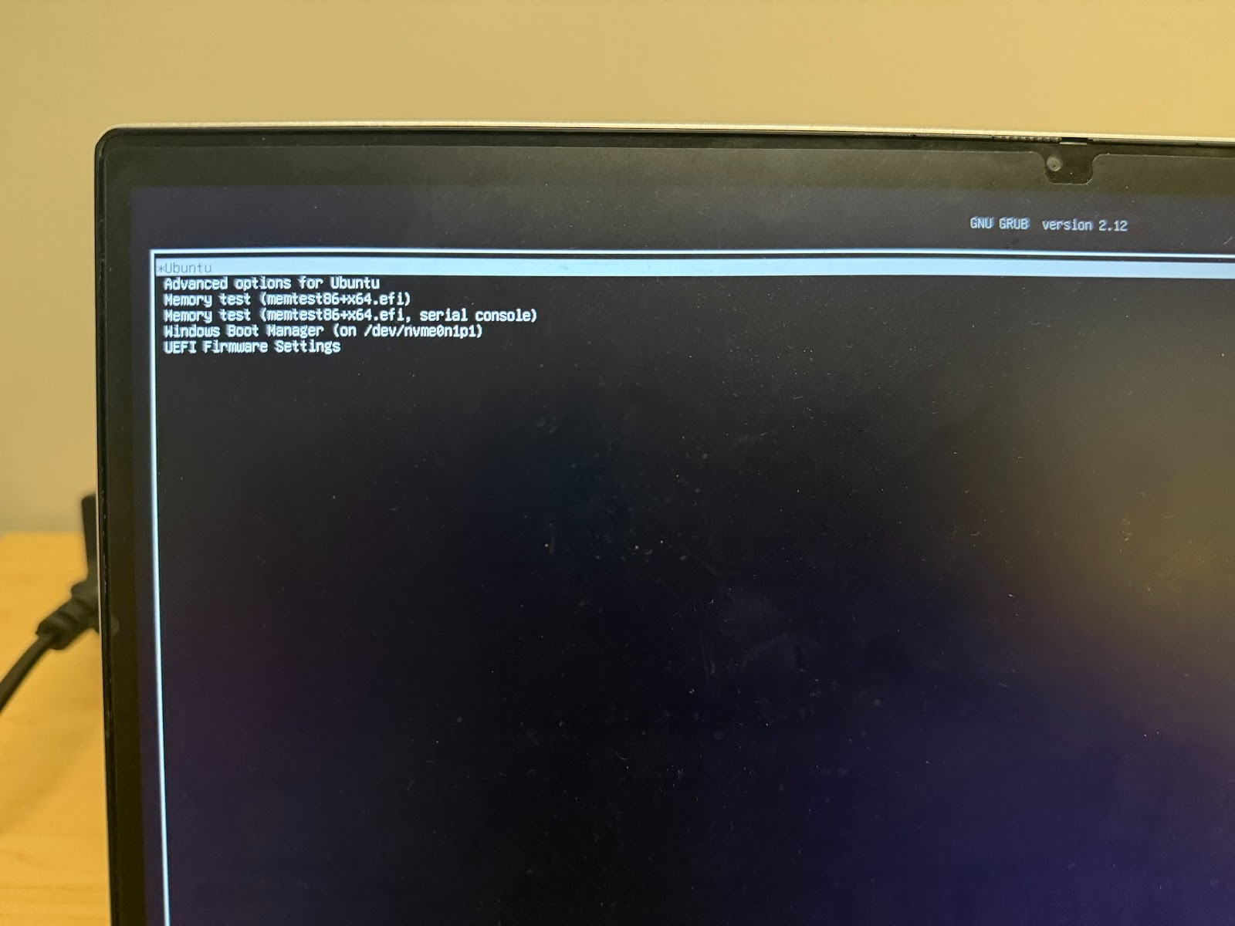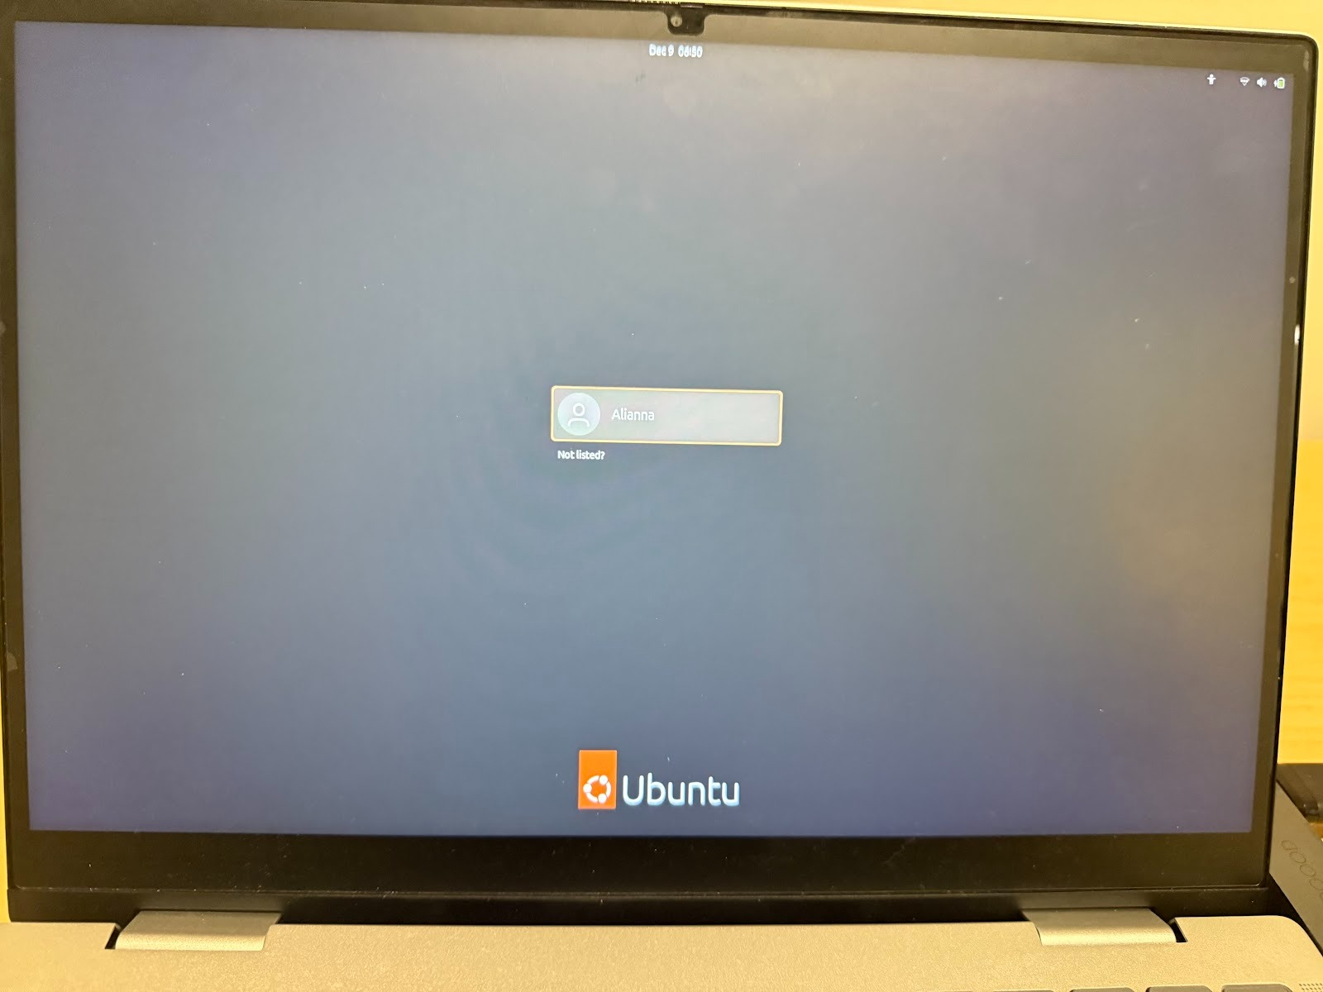

**Customizations:**

KDE Plasma Desktop Environment:

Explanation of why we chose this customization:

The KDE Plasma Desktop environment looks similar to windows, which is familiar to everyone on the team, making it a good customization to choose. Additionally, it was relatively easy to install in the terminal.

Implementation Steps:

First I ran sudo apt update to ensure everything was up to date

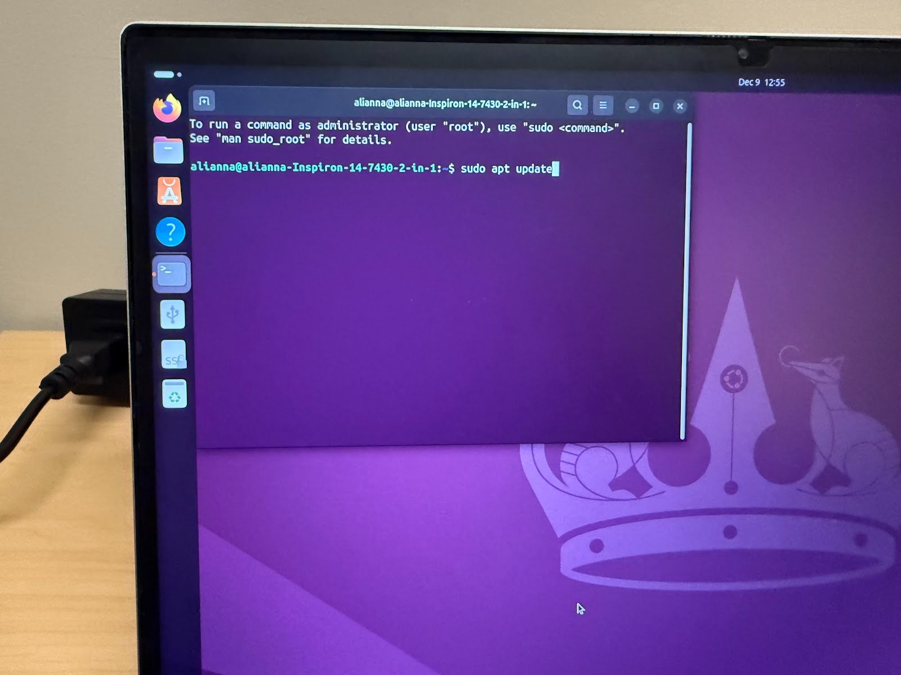

Then I ran sudo apt install kde-plasma-desktop

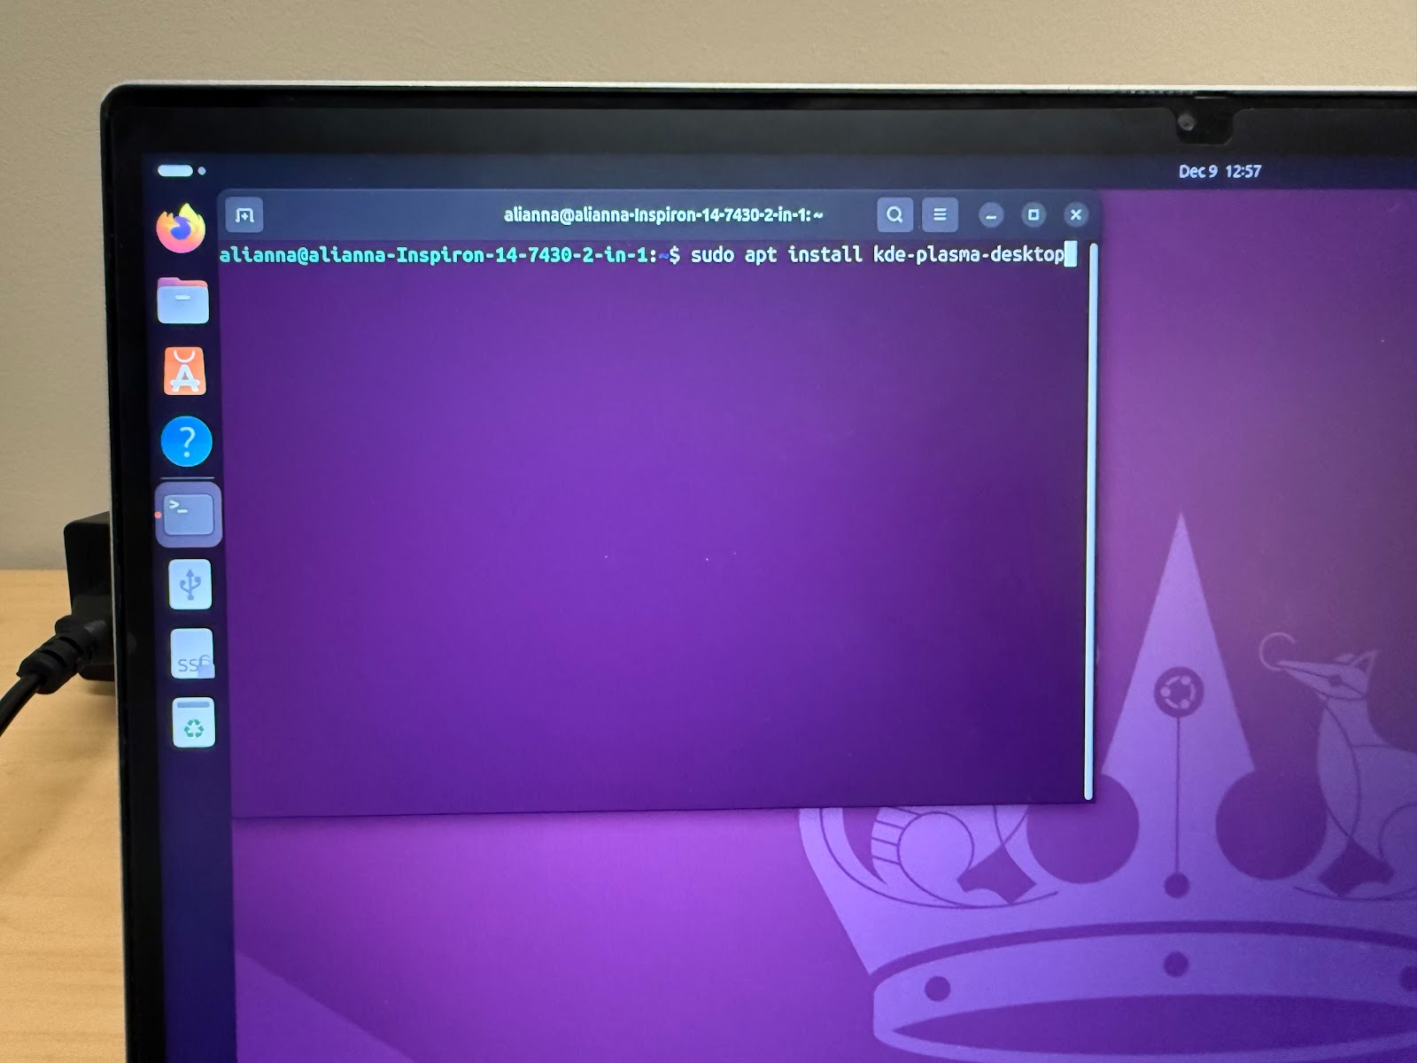

Below are a few pictures during the installation process. I chose gdm3 as the default display manager.

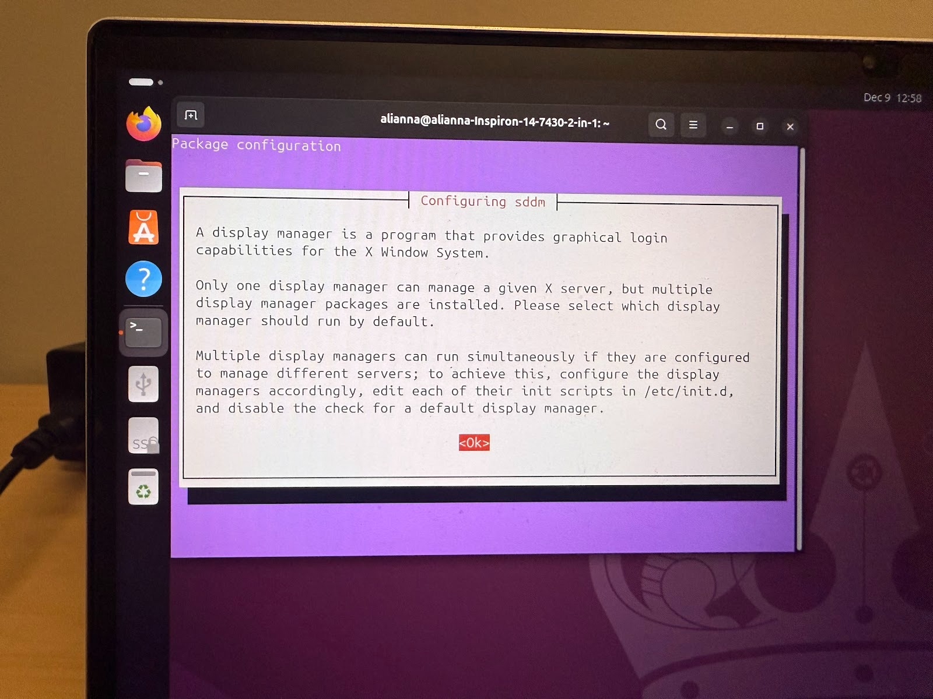 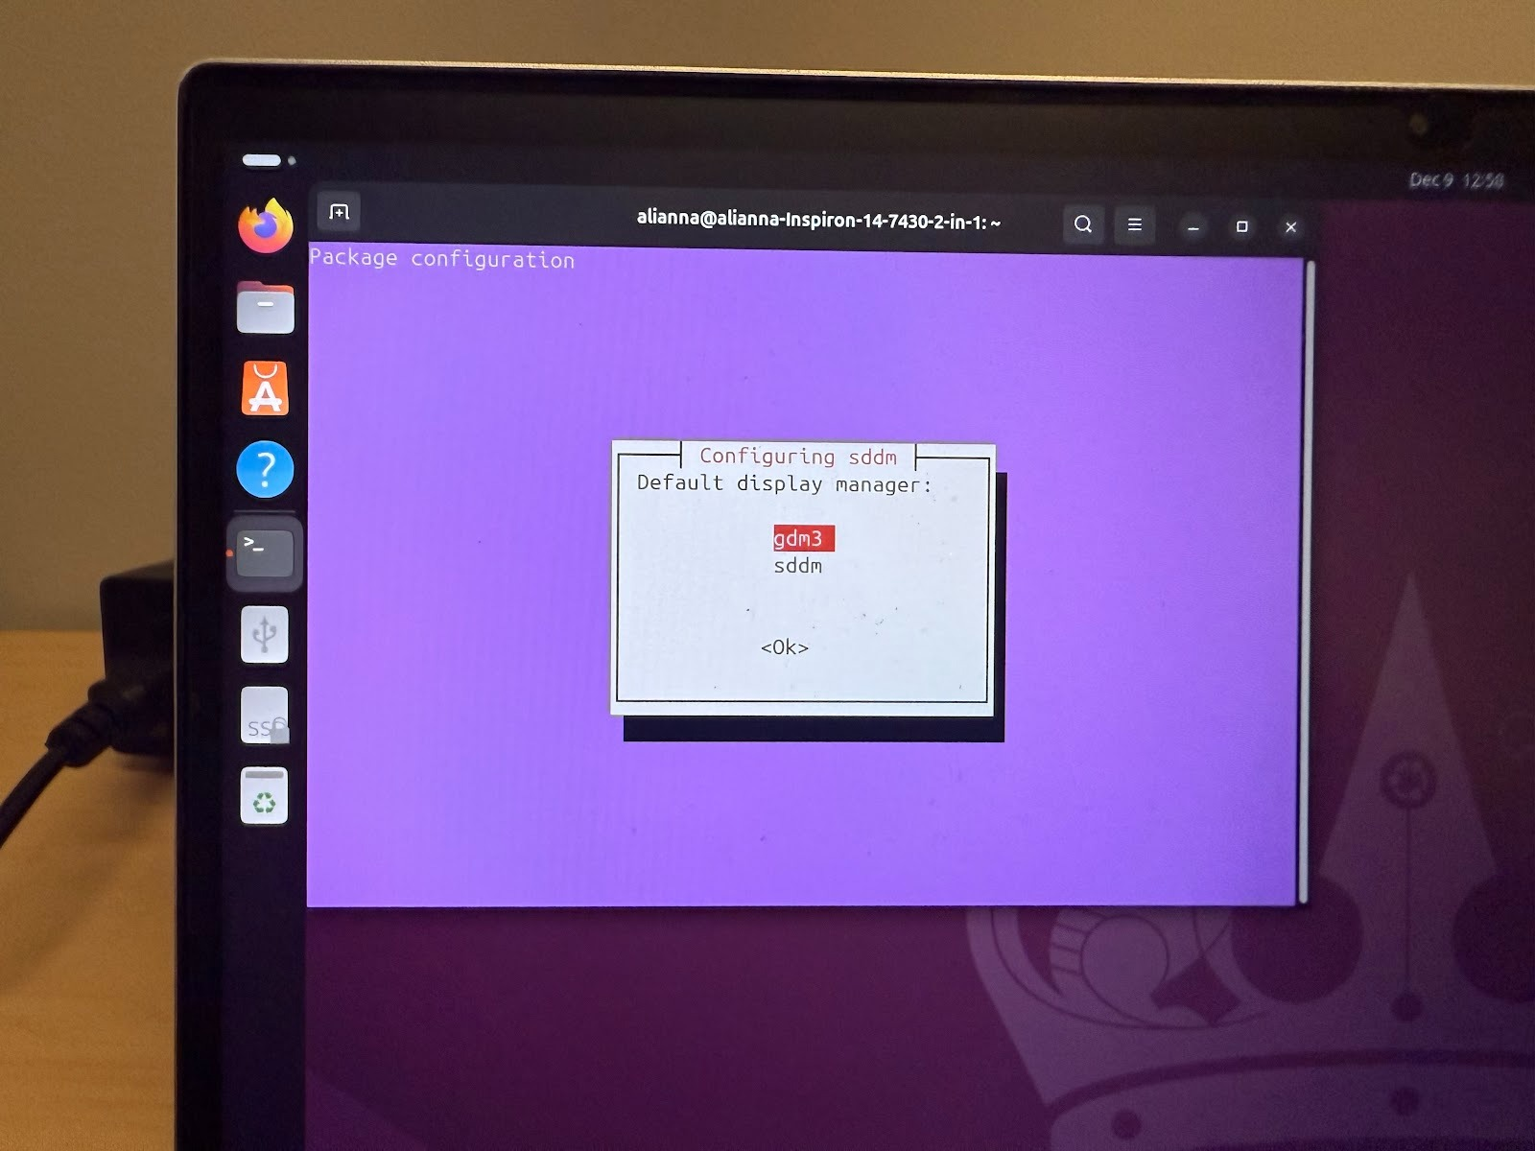

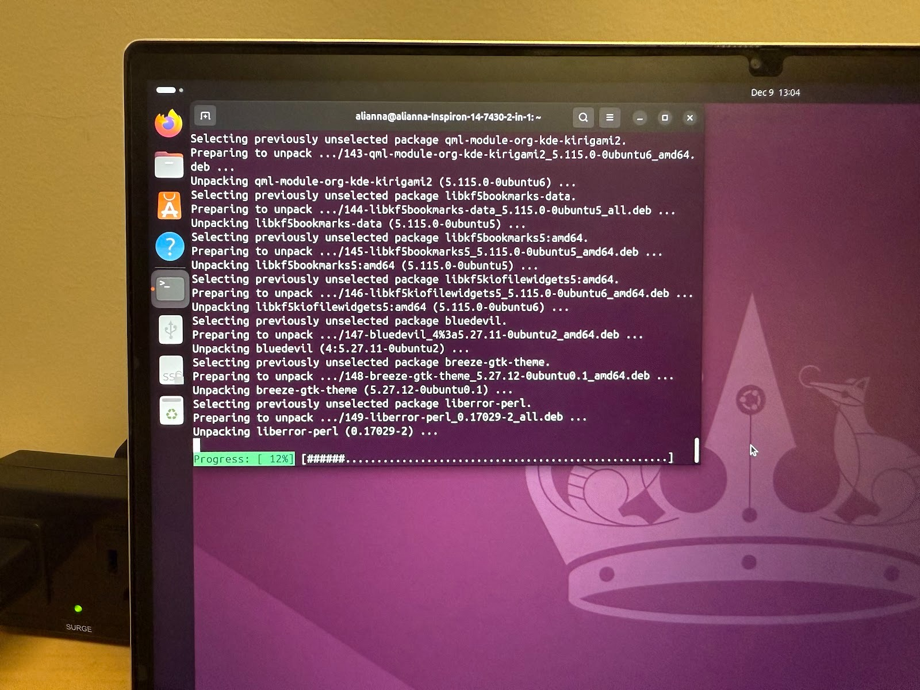

After the installation was complete, I ran sudo reboot to test it and see if it worked.

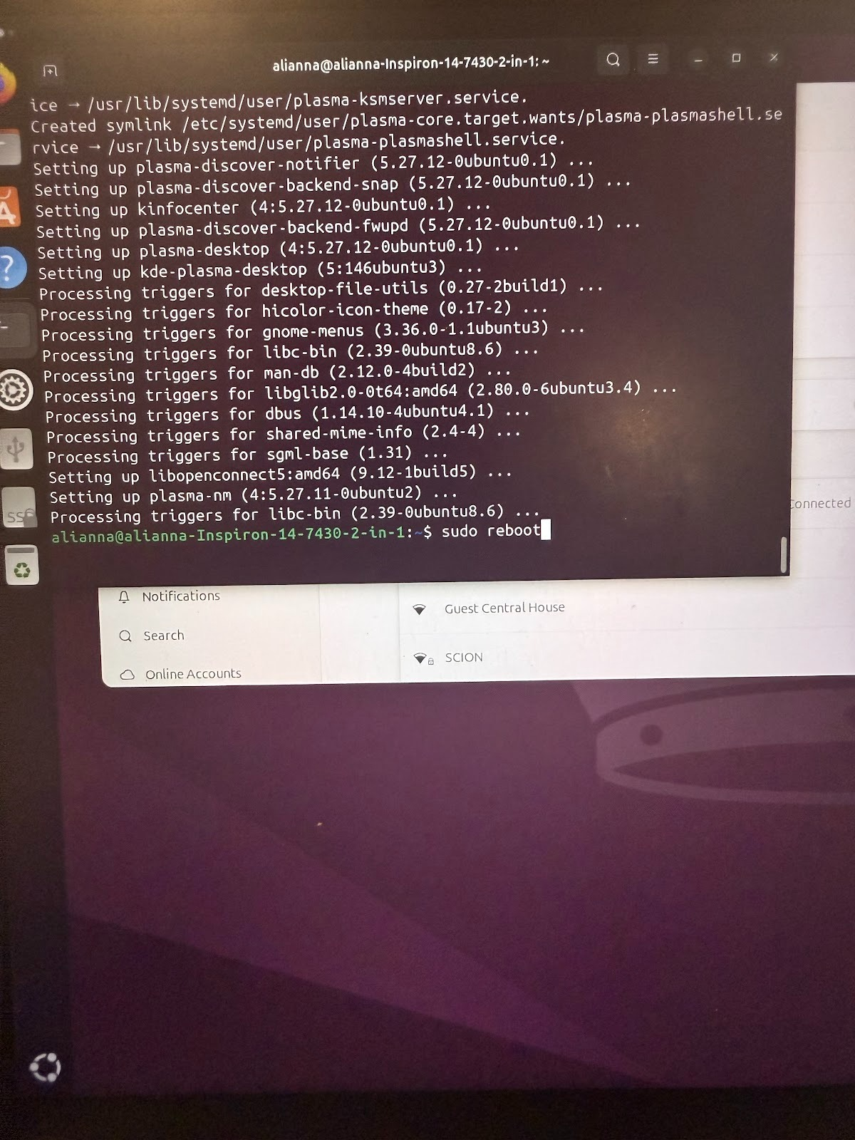

Customization Verification:

After rebooting, I chose plasma on the log in screen.

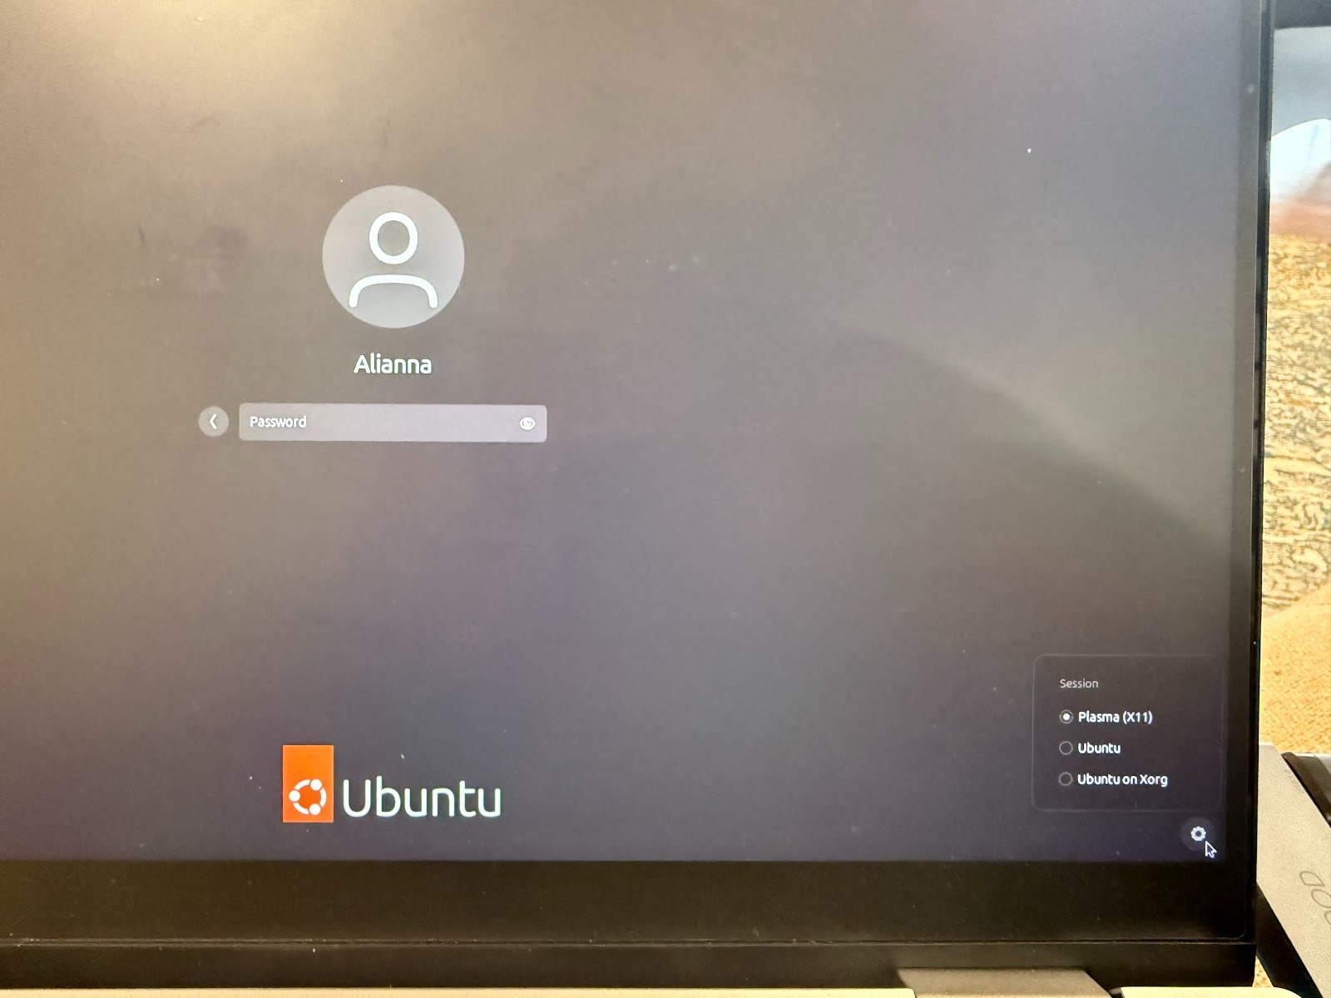

I logged in and it booted up with the new desktop environment.

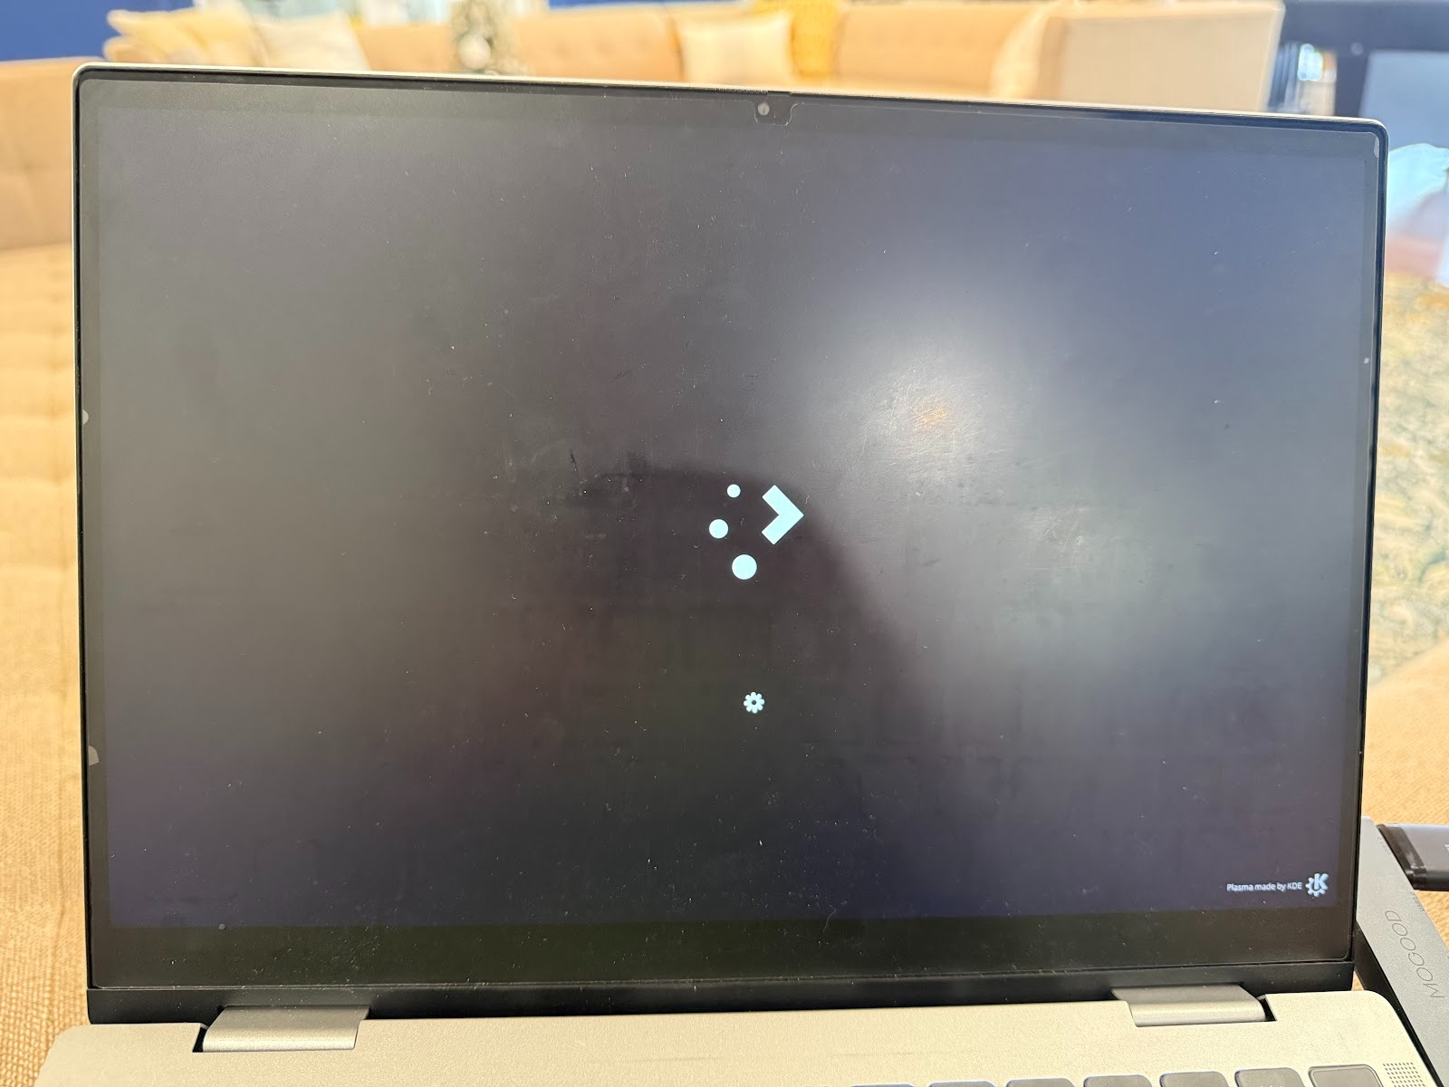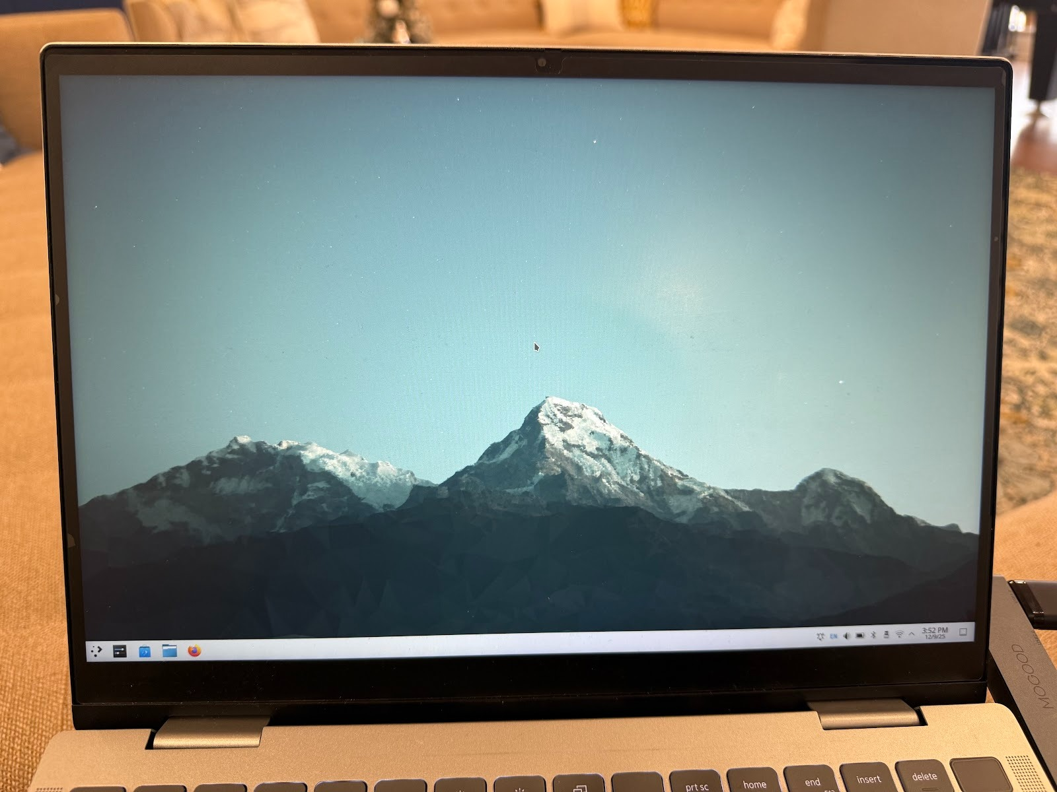

GNOME Software:

Explanation of why we chose this customization:

First, this customization seemed relatively simple to install as it could be installed through APT. Also, GNOME had some good general-purpose apps and a good store.

Implementation Steps:

I opened up the terminal and ran the sudo apt install gnome-software –install-suggests command. It installed very quickly

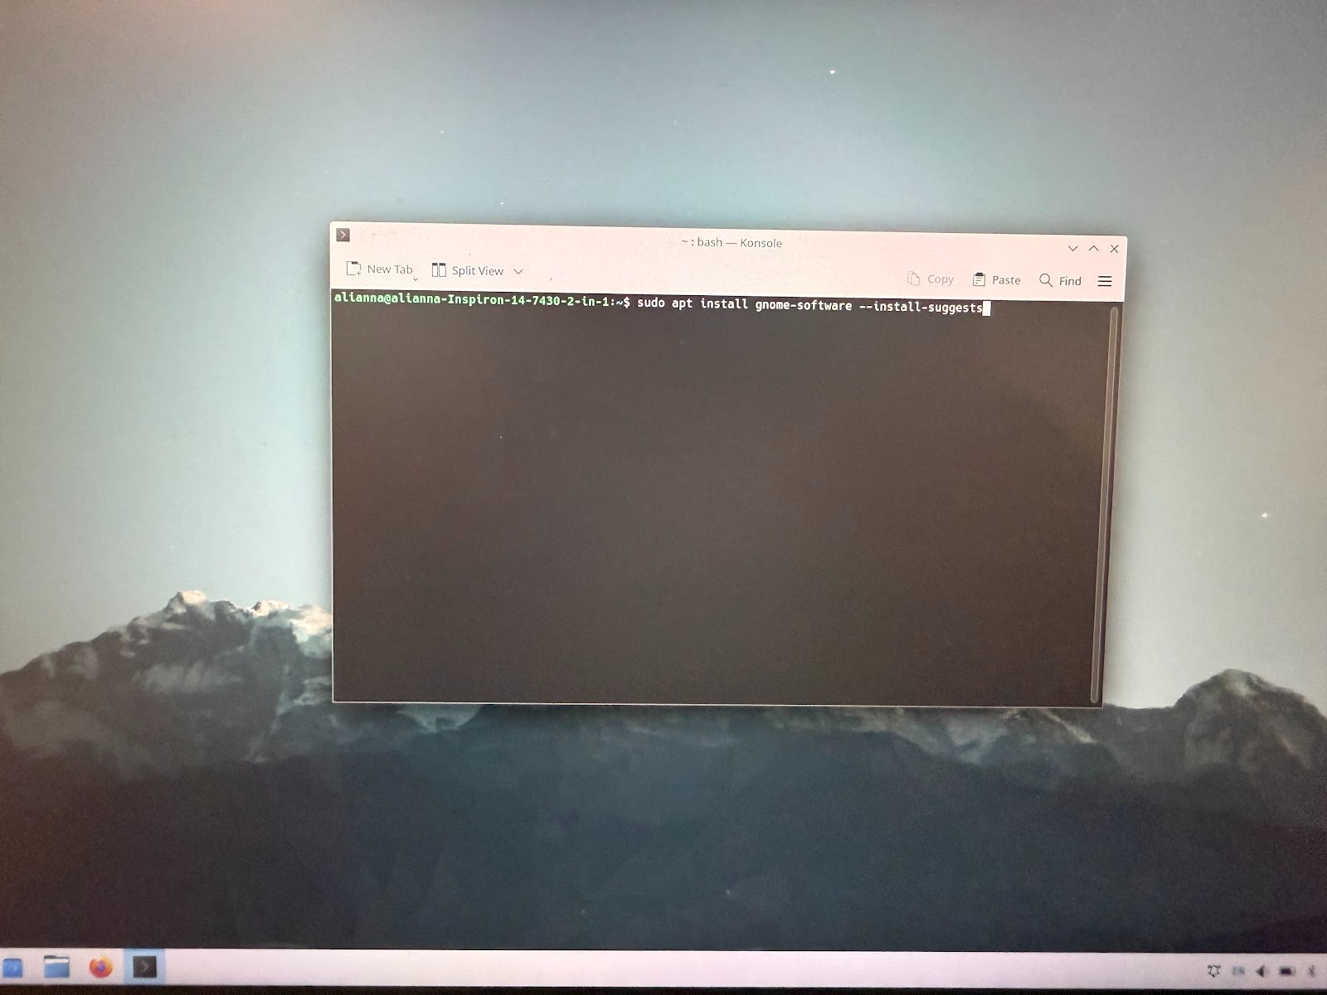

After running the above command, I ran gnome-software in the terminal to verify that it was installed correctly.

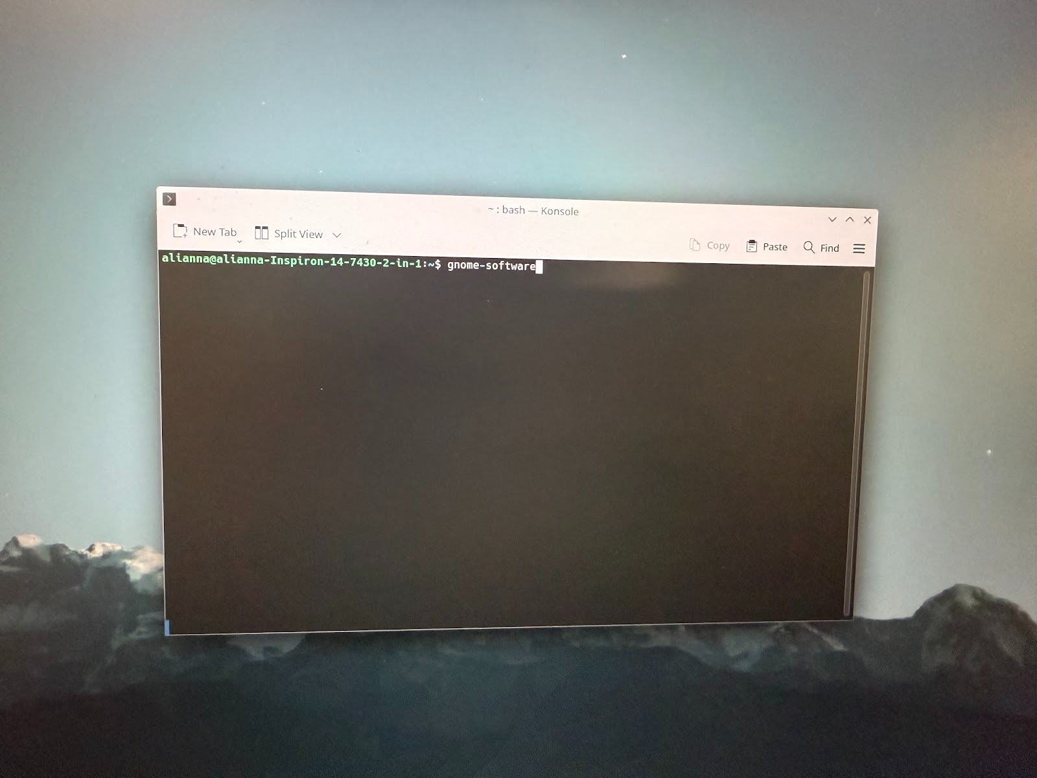

Customization Verification:

After running the gnome-software command, a separate window popped up, verifying that gnome-software was installed.

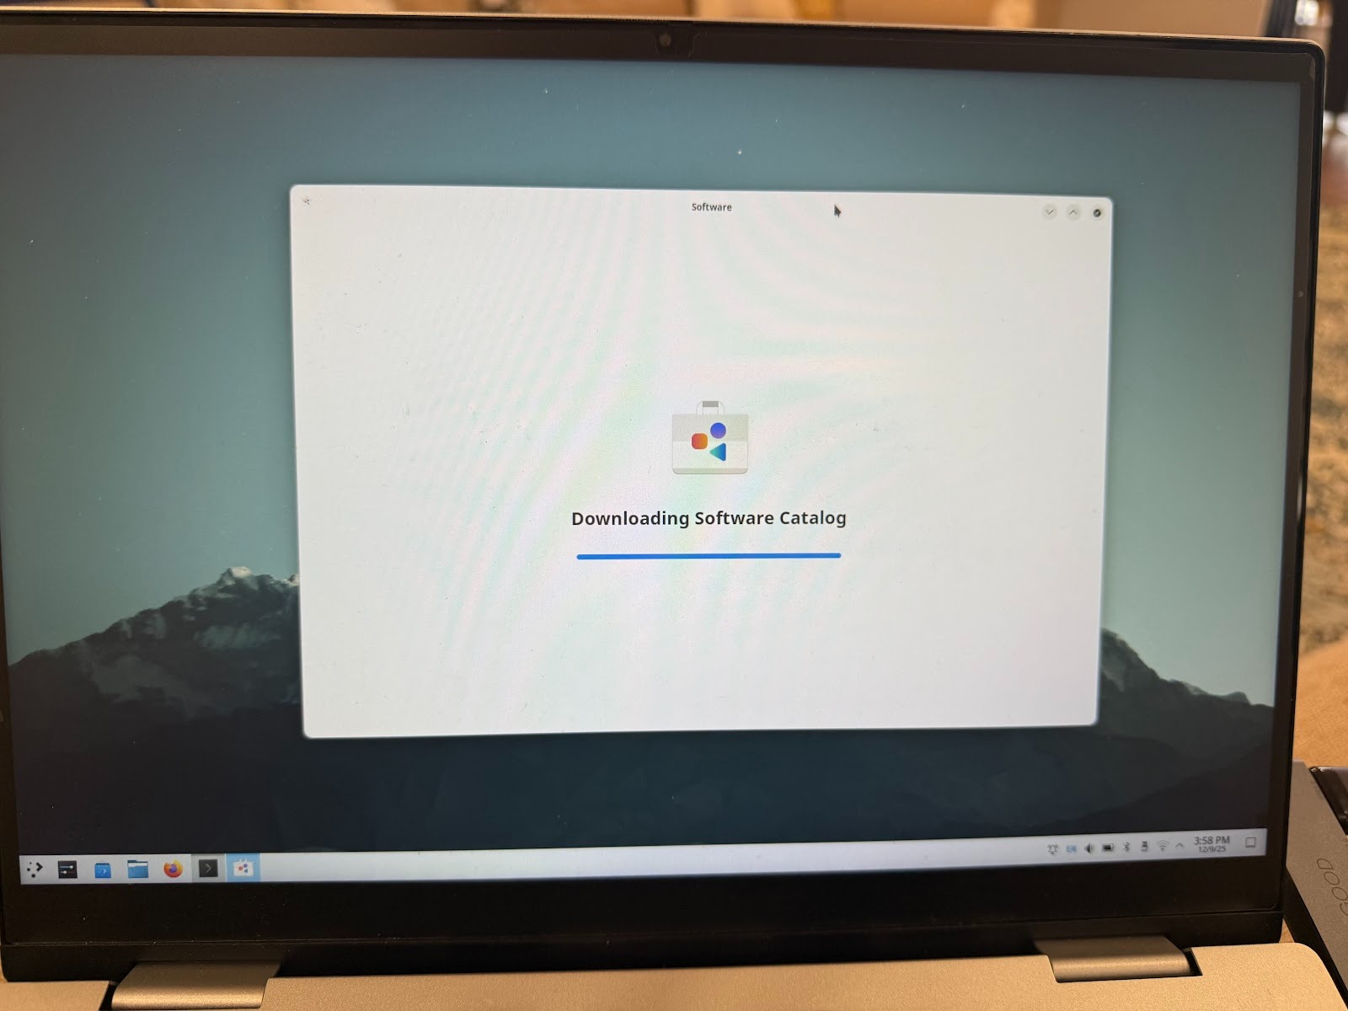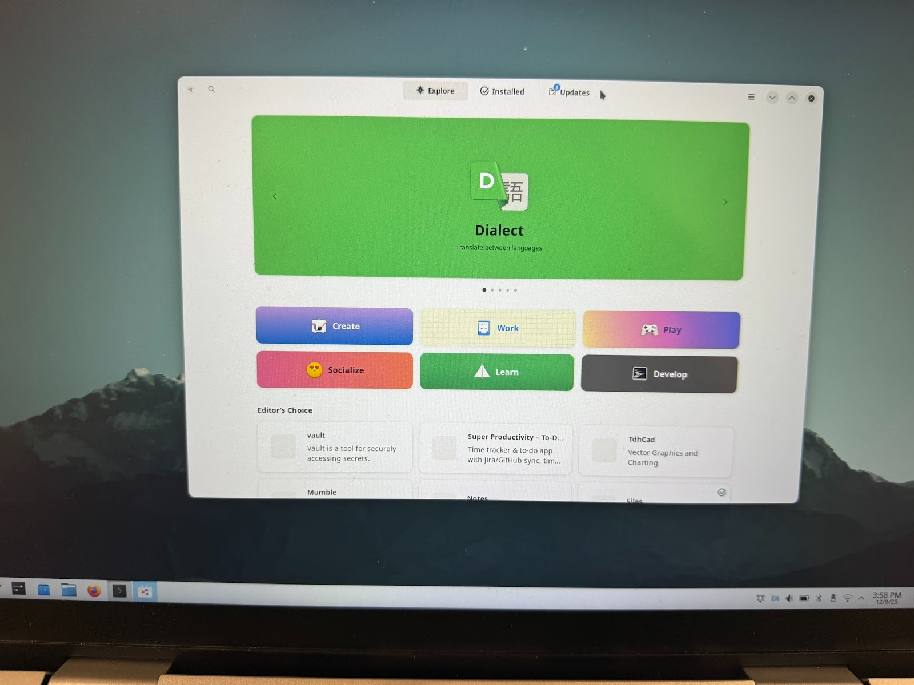

**Scripts:**

**icon.sh**:

Script function explanation: **Allows users to select scripts and an image to create a desktop file to easily run scripts like any other desktop application.**

**Asks user for script file via the zenity file explorer:**

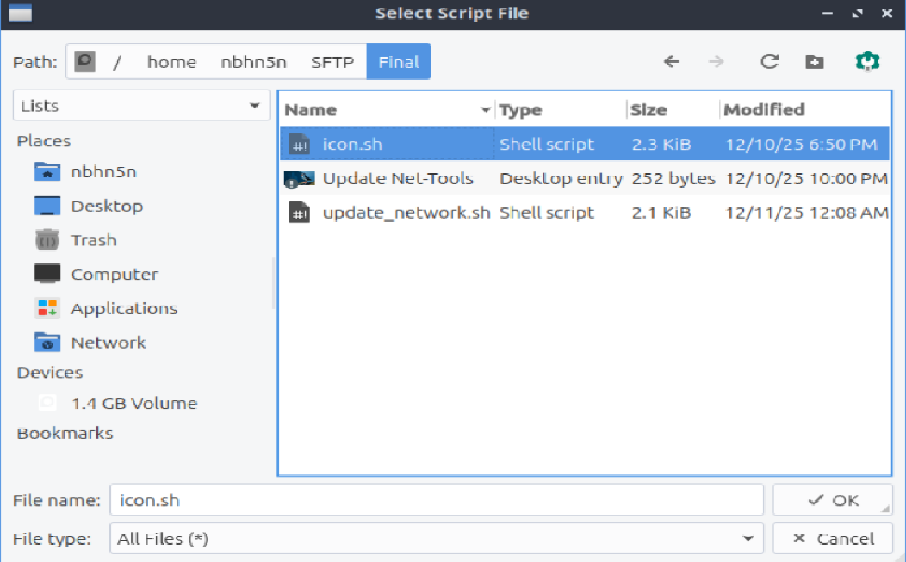Asks user for script icon via the zenity file explorer again:

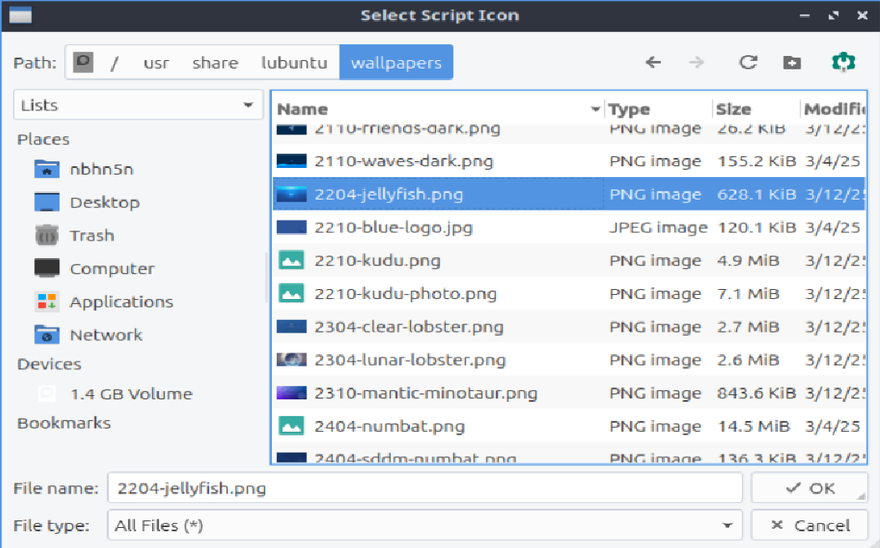Then prompts user for icon name through zenity text entry:

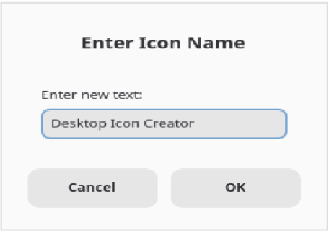

Successful creation and copying message is displayed

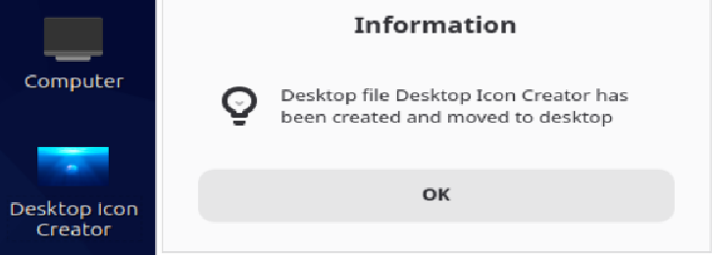

**cronjobs.sh**:

Script function explanation: This script provides a comprehensive scheduling system for automating Linux tasks using cronjobs. It presents users with a graphical interface to schedule predefined jobs [like - create_backup.sh (directory compression), update_packages.sh (system package updates), or update_network.sh (network configuration updates)]. The script guides users through selecting the date, time (with 12-hour AM/PM format for user convenience), and recurrence pattern (daily, weekly, monthly, or yearly). It then converts these user-friendly inputs into proper cron syntax and adds the scheduled job to the user's crontab.

Job Selection Menu Screenshot:

Calendar picker for selecting the job execution date

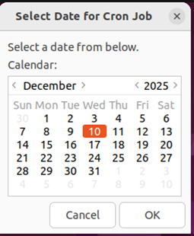

Time entry dialog requesting time in HH:MM 12-hour format

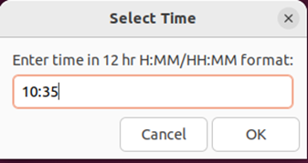

AM/PM selection dialog for 12-hour time format

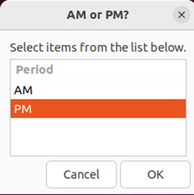

File browser for selecting the script to execute

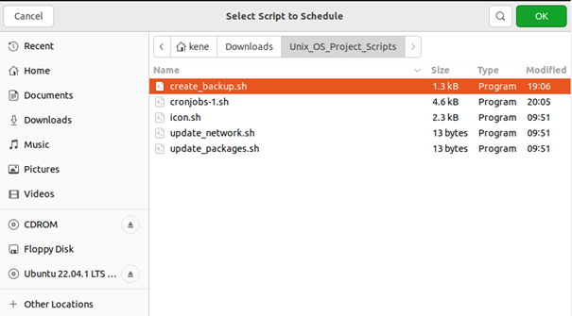

Dialog asking if script needs GUI access (for setting DISPLAY variables)

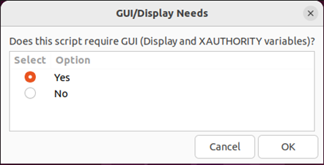

Repetition schedule options for job recurrence

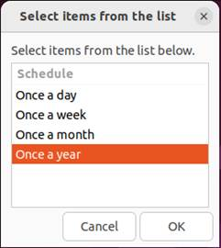

Scheduling Dialog Screenshot:

Final confirmation showing all schedule details and generated cron syntax

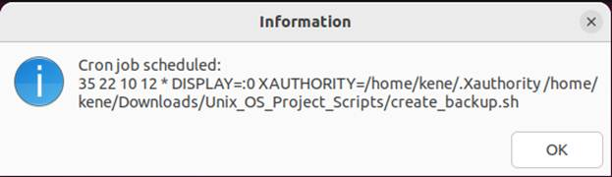

crontab -I Output Screenshot:

crontab listing showing the successfully scheduled job (10:35PM on December 10th every year) with proper cron syntax

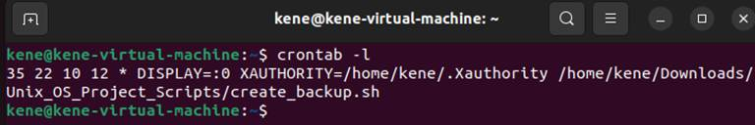

**create_backup.sh**:

Script function explanation: This script provides an easy-to-use GUI-based backup solution for Linux users. When executed, it prompts the user to select a source directory (the folder to backup) and a destination directory (where to save the backup) using Zenity dialog boxes. The script then creates a compressed tarball (.tar.gz file) of the source directory with a timestamp in the filename, making it easy to track when each backup was created. Upon completion, the script displays a success or failure message with details about the backup location.

Backup Process Screenshot:

Zenity dialog prompting user to select the source directory to backup

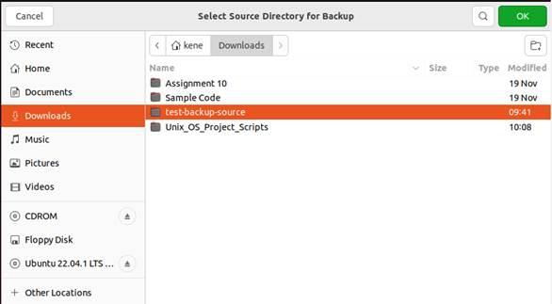

Zenity dialog prompting user to select the destination for where to save the backup

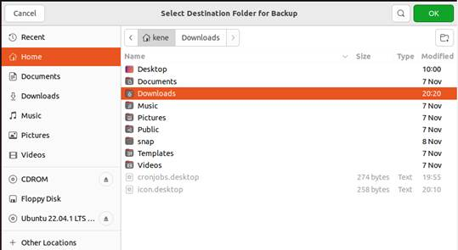

Success notification showing backup was created with filename and timestamp

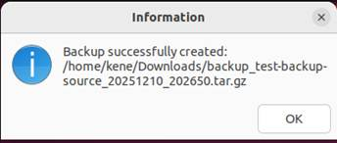

Backup Results Screenshot:

Backup file created in Downloads with timestamp in filename

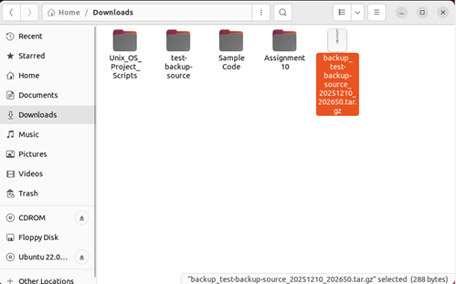

File contents verification - all data matches between original (top pic) and backup (bottom pic)

[test-backup-source]: 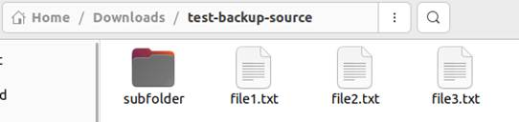

[backup_test-backup-source]: 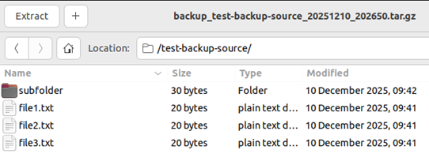

**update_packages.sh**:

**Script function explanation:** Updates predefined package lists (curl, vim, git, bash) on ubuntu. Displays the list of packages to the user, running apt update to refresh the package repository, then looping through each package to upgrade packages that are already installed. Progress is shown using Zenity GUI dialog boxes. The script tracks which packages were successfully updated and which failed, displaying the result including the count of successful and failed packages along with which packages failed.

Initial predefined package list to be updated displayed to the user

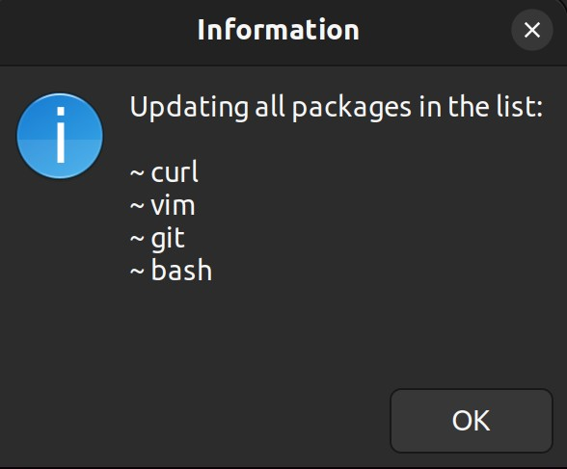

Successful execution of all packages result displaying to the user

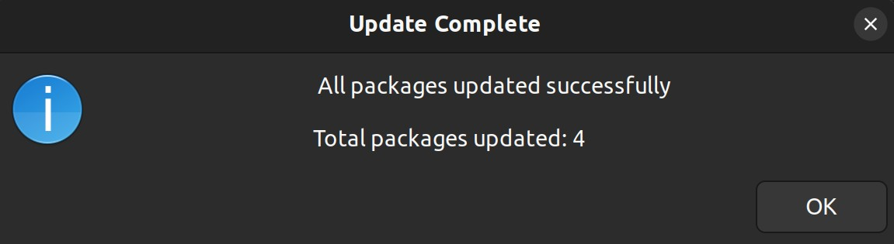

Execution result with failures using a test package displayed to the user

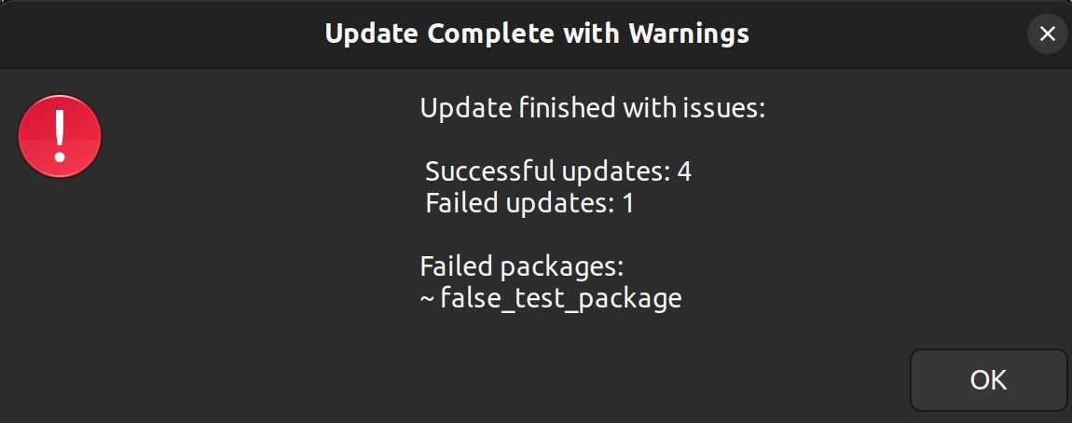

Output in the terminal showing bash package was successfully checked and is up to date already (no upgrades or new installations required).

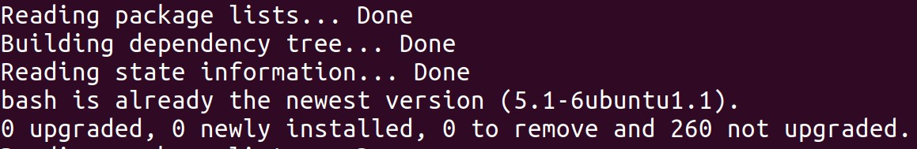

**update_network.sh**: Updates selected network related packages and displays basic network status information to the terminal. Uses a list of packages to execute their commands to check if they are present. First it tries to ping Google’s DNS and if not possible it will not try to update the packages. If connected to the internet each package will be identified as present or not present and updated or installed through apt install accordingly. At the end network information from “ip a” command will be displayed along with possible dependency updates. Requires terminal execution and sudo password.

Screenshot from testing:

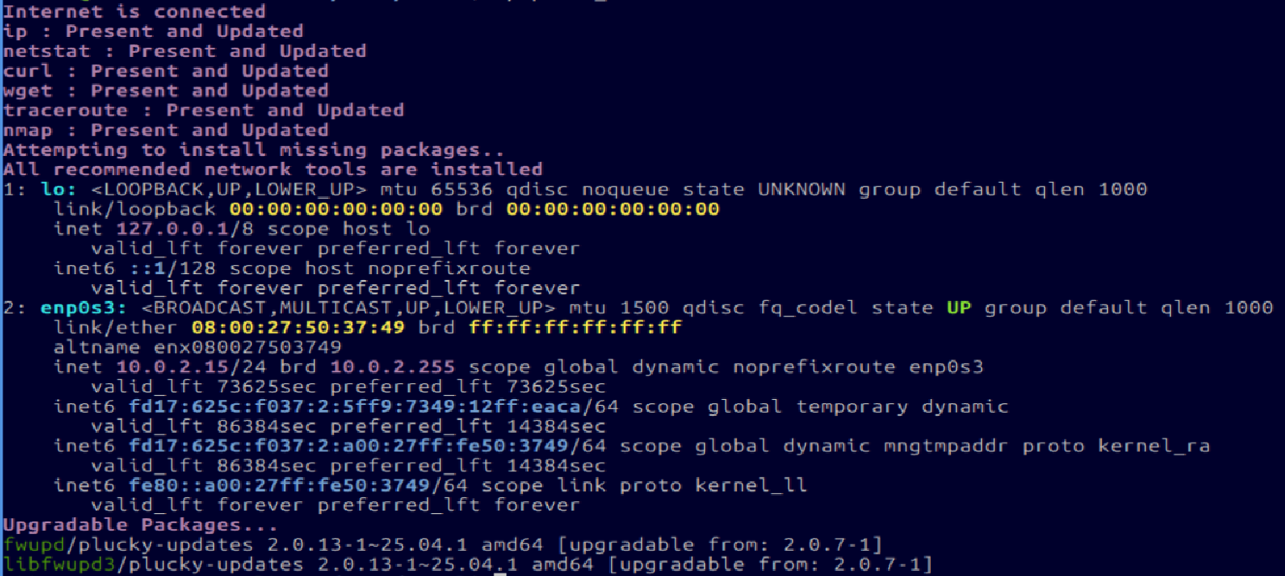

**Conclusion & Takeaways**:

In conclusion, this project is demonstrating that Linux is a highly customizable and flexible operating system. Each component of this project, distribution, desktop environment, applications, and automation scripts are choices that any person who wants to use Linux can consider changing their own preference or utility. There are thousands of distributions that are tailored to virtually every use case. We didn’t even have to put the OS on an actual computer demonstrating Linux’s flexibility. The appearance (KDE-plasma) and applications (GNOME Suite) chosen allow for a more streamlined and personalized experience. The ease of making bash scripts is a powerful tool for automating routine tasks associated with system administration, development tasks, or any other application. This project is a testament to Linux being a open-source platform for making computers work for you and your needs.